Academic Governance & Administration Framework
Final – January 23, 2020

Endorsed by: Academic Council and Elders Council | Approved By: Board of Governors | Prepared by: Vice-President, Academic | Date issued: | Supersedes/New:

Table of Contents

SECTION 1: OVERVIEW OF FNUNIV ACADEMIC GOVERNANCE & ADMINISTRATION
  - Framework Purpose 4
  - Alignment with Strategic Plan 5
  - Academic Management Contacts 6
  - Governance Structure 7
  - Program Structure 10
  - Administration Structure & Roles 10
  - Decision Making & Responsibility Summary 13
SECTION 2: TERMS OF REFERENCE FOR ACADEMIC GOVERNANCE BODIES
  - Academic Council Terms Of Reference 17
  - Curriculum Review Committee Terms Of Reference 20
  - Committee On Academic Policies Terms Of Reference 21
  - Academic Performance Review Committee Terms Of Reference 22
  - Program Council Terms Of Reference 23
  - Elders Council Terms Of Reference 25
  - Senior Academic Management Team Terms Of Reference 27
SECTION 3: ACADEMIC ADMINISTRATION ROLE DESCRIPTIONS
  - Vice-President, Academic – Role Description 29
  - Associate Dean, Academic – Role Description 32
  - Associate Dean, Community, Research & Graduate Programs – Role Description 35
  - Program Coordinator – Role Description 38
  - Academic Administrator – Role Description 39
SECTION 4: KEY ACADEMIC ADMINISTRATION POLICIES & PROCEDURES
  - Annual Academic Plan & Budget Development 42
  - Academic Scheduling 47
  - Hiring Academic Staff (Non-Faculty) 54
  - Academic Staff (Non-Faculty) Contracts Development 60

SECTION 1:

OVERVIEW OF FNUNIV ACADEMIC GOVERNANCE & ADMINISTRATION

Framework Purpose
The First Nations University of Canada supports the recommendations of the Truth and Reconciliation Commission of Canada Calls to Action, National Inquiry of Missing and Murdered Indigenous Women and Girls, and the United Nations Declaration on the Rights of Indigenous Peoples.

The purpose of the First Nations University of Canada (FNUniv) Academic Governance & Administration Framework (the Framework) is to ensure effective and efficient academic administration for quality academic delivery for students and enabling faculty to focus on high value teaching outcomes. The Framework provides consolidated documentation of the way the institution’s academic programming is governed and administered. The Framework summarizes the governance and administration structures for FNUniv academic programming to provide clarity on decision making authorities and administration roles and responsibilities. The Framework governs FNUniv’s internal academic administrative structure and decision making processes. The University of Regina (U of R) has entered into a federated agreement with the FNUniv. The agreement states that as a federated college that the FNUniv is legally and financially independent but academically integrated with the U of R. This Framework should not be interpreted and implemented in a manner that would contravene the Federation Agreement.

In addition, key academic policies, processes and procedures have been included to provide clear documentation to improve consistency, efficiency and effectiveness of academic administration for all leadership, faculty and staff involved.

This is the first version of the FNUniv Academic Governance & Administration Framework. The intent is to have additional policies and procedures continually added to the Framework over time for more comprehensive documentation. This Framework will undergo regular reviews and updates to ensure it is current and enable opportunity for continuous improvement. All updates will be communicated and shared with faculty and administration staff.

Alignment with Strategic Plan
The development and issuance of this Framework aligns with the institution’s 2019 – 2024 Strategic Plan – ôtê nîkân (“in the future”). It will result in positive outcomes for all four of the strategic processes – Teaching & Learning, Student Success, Communications & Collaboration. Improving consistency and efficiency of academic administration will:

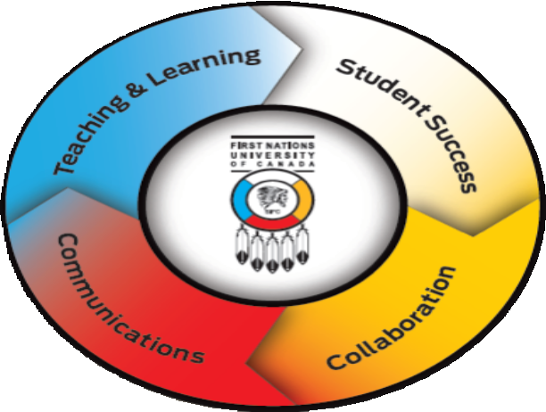
    - allow leadership and faculty to spend more time focusing on quality teaching and strategic discussions around pedagogical practices and delivery options to result in improved educational experience for students,

    - enable increased focus on strengthening partnerships and relationships;

    - improve collaboration and employee and staff satisfaction through improved documentation supporting effective and efficient program and operational administration; and

    - overall create an operating environment that has advantages for all – including students, academics and administrators.

Academic Management Contacts

OFFICE OF THE VICE-PRESIDENT, ACADEMIC
Vice-President, Academic Dr. Bob Kayseas
Executive Assistant to Vice-President, Academic Denise Kaiswatum
Associate Dean, Academic <Name>
Associate Dean, Community, Research & Graduate Programs <Name> Academic Administrator <Name>

PROGRAM COORDINATORS
Indigenous Business & Public Administration <Name>
Indigenous Communication & Arts <Name>
Indigenous Education <Name>
Indigenous Health <Name>
Indigenous Languages <Name>
Indigenous Literatures in English <Name>
Indigenous Social Work <Name>
Indigenous Studies <Name>
Indigenous Knowledge & Science <Name>

REGISTRAR’S OFFICE
Registrar Lianda Tanner

STUDENT SUCCESS SERVICES & ELDER SERVICES
Director Kim Fraser-Saddleback

Governance Structure
The following governance structure includes the key councils and committees involved in leadership and decision making for governance of academic delivery at FNUniv. The chart highlights relationships related to those that are involved in providing direction, approvals and oversight versus those stakeholders that are kept informed and engaged on strategic issues and academic matters for input and recommendations, but not involved in decision making. The policies and procedures included in Section 4 are to be followed to ensure planning, input and decision-making processes through this governance structure is as efficient and timely as possible in order to be responsive to our students, our faculty and staff, and partners.

Further description of each of the governance bodies is provide below and associated Terms of References are included in the appendix.
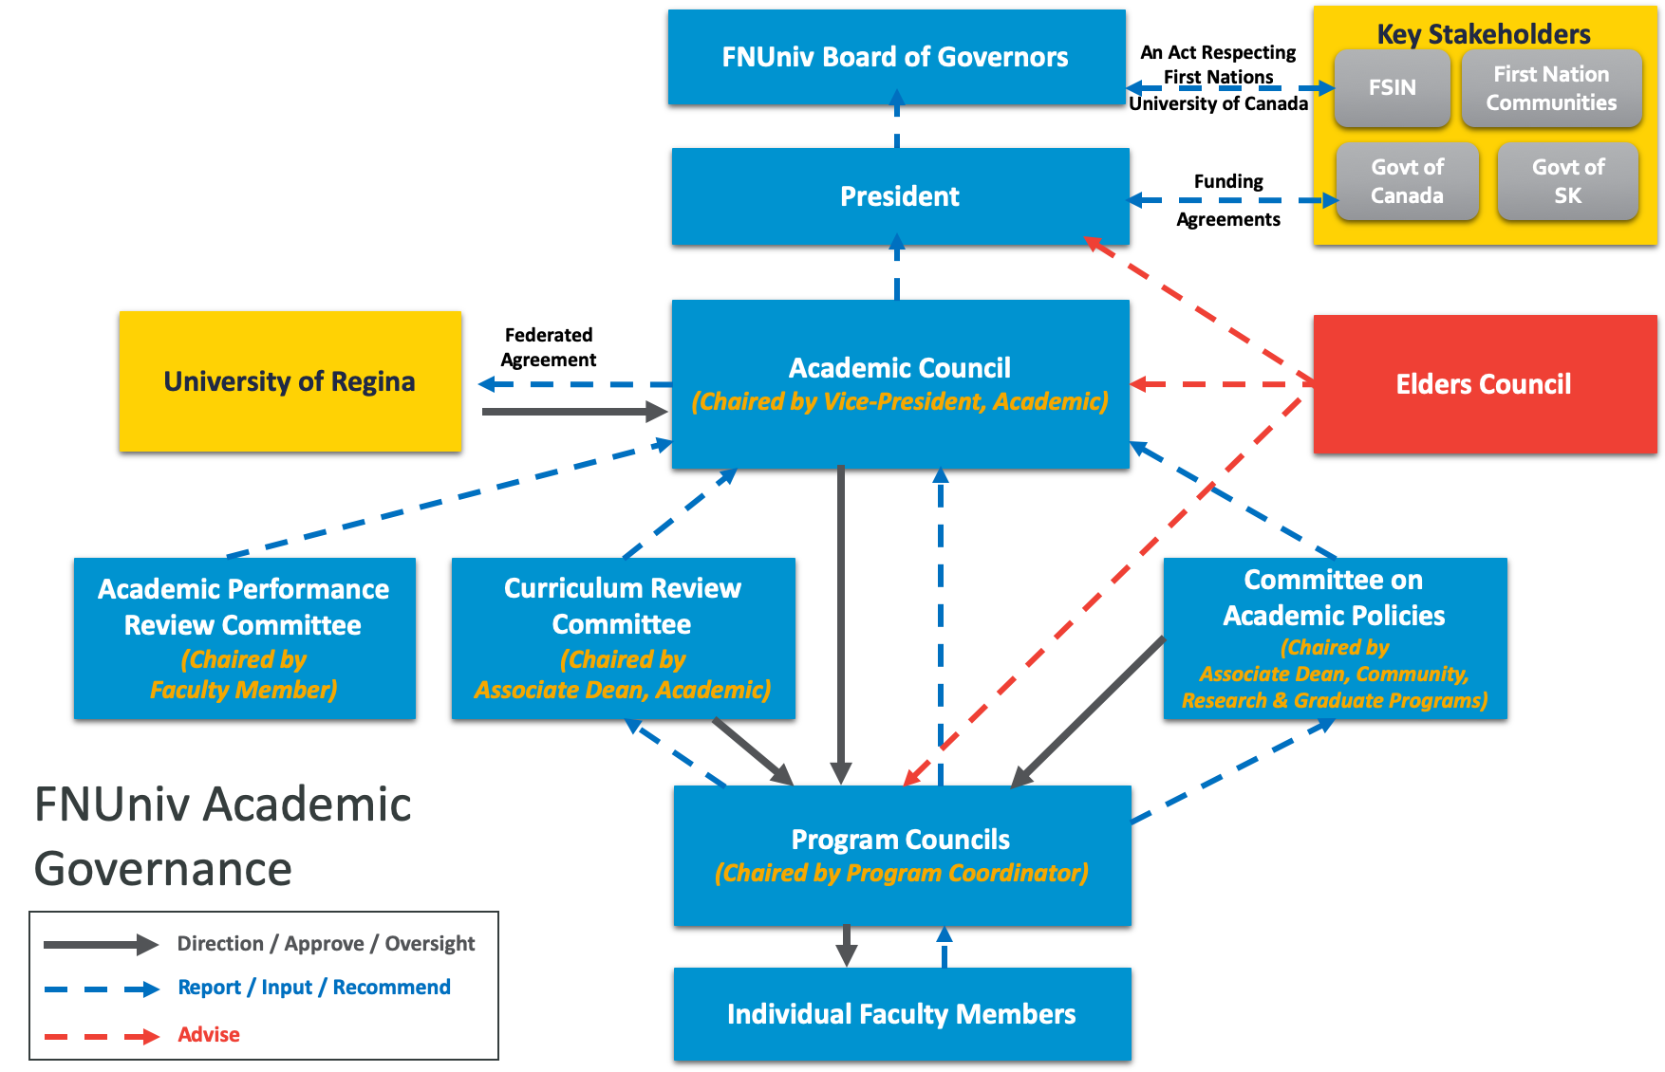

ACADEMIC COUNCIL
Academic Council shall have oversight over all decisions affecting the content,, composition and delivery of academic programs offered by FNUniv.. It is responsible for ensuring academic and administrative compatibility with its agreements with its federated partner, the University of Regina. Academic Council approves any academic plans which then directs administration staff’s execution and support efforts.
FNUniv Academic Council is chaired by the Vice-President, Academic and comprised of tenure and tenure track faculty members holding academic rank at the institution, three sessional representatives, and ex officio members including the Academic Administrator, Registrar and Director of Student Success Services. Elders and student representatives participate upon invitation but do not have voting privileges. Academic

Council meets quarterly and meetings have an agenda, minutes and records of decisions. Academic administration is delivered in accordance to all the terms and articles of the Collective Bargaining Agreements. The Terms of Reference for Academic Council is included in Section 2.

CURRICULUM REVIEW COMMITTEE
As a sub-committee of Academic Council, the Curriculum Review Committee (CRC), in coordination with the relevant University of Regina academic unit, reviews and makes recommendations to Academic Council on new programs, courses and changes to existing programs/courses. The CRC is comprised of the Associate Dean, Academic as Chair, and Program Coordinators from each FNUniv Program area, resulting in 10 voting members in addition to the Vice-President, Academic; Associate Dean, Community, Research & Graduate Programs; and Registrar as ex-officio members. The Associate Dean, Academic chairs the CRC and the Registrar is available as alternate Chair and secretarial support. The CRC meets quarterly in advance of Academic Council meetings. Meetings have an agenda, minutes and records of decisions. The Terms of Reference for the Curriculum Review Committee is included in Section 2.

COMMITTEE ON ACADEMIC OVERSIGHT
As a sub-committee of Academic Council, the Committee on Academic Oversight (CAO) makes recommendations to Academic Council on all matters regarding delivery of academic programs. It shall, for FNUniv and in consultation with program areas, develop proposals for the establishment and continuous review of academic policies and processes, procedure statements and structures. CAO is comprised of the Associate Dean, Community, Research & Graduate Programs (Chair); Associate Dean, Academic; three faculty representatives; three staff representatives (Director of Student Success Services, the Registrar and Academic Administrator); and 1 supporting staff. CAO meets quarterly in advance of Academic Council meetings. Meetings have an agenda, minutes and records of decisions. The Terms of Reference for the Committee on Academic Oversigh is included in Section 2.

ACADEMIC PERFORMANCE REVIEW COMMITTEE
As a sub-committee of Academic Council, the Academic Performance Review Committee (APRC) is involved with the performance review of fellow faculty members, providing recommendations to the Vice- President, Academic regarding career growth increments, renewal of probationary appointments, permanent appointments, and promotion. The APRC will consist of four members of permanent academic staff at or above the rank of assistant professor. The APRC members will be elected by academic staff.
The APRC is chaired by an elected faculty member. The Terms of Reference for the Academic Performance Review Committee is included in Section 2.

PROGRAM COUNCIL
Program Councils are comprised of the faculty members within a FNUniv Program area (see Section 1.5 for further information on Program Structure). Programs are led through collegial governance, planning and decision making as initiated by individual Program Councils, supported by an appointed Program Coordinator (faculty member) to facilitate recommendations to FNUniv academic administration roles and the appropriate governing bodies. Program Councils are responsible for recommendations on the annual academic plan and budget; new business cases; program quality, maintenance and creation; technology enhancements for distance delivery; curriculum creation and revisions; community-based programming requirements; faculty hiring and budget oversight. The Terms of Reference for Program Councils is included in Section 2.

ELDERS COUNCIL
The First Nations University of Canada Elders Council promotes unity of member First Nations through the promotion and preservation of Indigenous heritage, knowledge, culture, values, and customs. The purpose of the Elders Council is to enhance the quality of life, and to preserve, protect, and interpret the history, language, culture, and artistic heritage of First Nations. It assists FNUniv faculty, students, and staff and

First Nations in the revival and re-institution of their spiritual heritage, knowledge, culture, customs, and traditions and acts as advisors regarding Indigenous knowledge and spiritual practices and protocol as the stabilizing influence in First Nations society. The Terms of Reference for the Elders Council is included in Section 2.

SENIOR ACADEMIC MANAGEMENT TEAM
The Senior Academic Management Team (SAMT) is comprised of the Vice-President, Academic (Chair); the Associate Dean, Academic; the Associate Dean, Community, Research & Graduate Programs; the Academic Administrator; the Registrar; and the Director of Student Success Services. The SAMT collaborates to ensure delivery of FNUniv’s academic plan in accordance with the budget, through effective and efficient academic administration to achieve student outcomes. The Terms of Reference for the Senior Academic Management Team is included in Section 2.

RELATIONSHIP TO FNUNIV PRESIDENT & BOARD OF GOVERNORS
Approvals related to institutional budget and strategic hiring involve the President and Board of Governors. However, academic decisions are within the purview of the Vice-President, Academic and Academic Council, in alignment with supporting the strategic plan and requirements of the Federation Agreement with the University of Regina.

RELATIONSHIP TO FIRST NATIONS
The First Nations University of Canada was established in 1976 under the authority of the Saskatchewan First Nations, as an academically integrated and independently administered institution to serve the academic, cultural and spiritual needs of First Nations and society in general.

RELATIONSHIP TO UNIVERSITY OF REGINA
FNUniv is a federated college of the University of Regina, as per the Federation Agreement between the two institutions. This means FNUniv is a post-secondary institution, legally and financially independent and administratively autonomous but academically integrated with the University of Regina. FNUniv offers courses in mutually agreed upon disciplines, which are part of certificate or degree programs of the University of Regina. The academic standards of FNUniv are governed by the University of Regina’s Senate Bylaws. FNUniv selects and appoints its own professors, provided the University of Regina approves their academic qualifications. FNUniv’s President, Vice-President, Academic and faculty are voting members of the Faculty of Arts, Faculty of Science or such other Faculties as are approved in the Federation Agreement and are members of Council. The President is a member of Senate.

RELATIONSHIP TO GOVERNMENT OF CANADA
FNUniv receives funding through a proposal-driven process from the Government of Canada through the Post-Secondary Partnership Program. Funding is provided through contribution agreements and the FNUniv must deliver programs in accordance with the provisions of these funding agreements. FNUniv is responsible for ensuring that quarterly reporting requirements are met as per the agreements.

RELATIONSHIP TO GOVERNMENT OF SASKATCHEWAN
As a post-secondary institution in Saskatchewan, FNUniv receives funding from the Government of Saskatchewan through its budget proposal process. Funding is provided through a funding agreement and FNUniv is required to deliver and meet reporting requirements as specified in the agreement. FNUniv has a very collegial relationship with the Government of Saskatchewan as part of the post-secondary sector in the province.

Academic Program Structure
FNUniv Program areas are organized as follows, each led through collegial governance and decision making through their respective Program Councils, with support from an appointed Program Coordinator (faculty member) for day-to-day decision making. All academic administration will be centrally delivered as directed by the Academic Plan to ensure faculty are focused on teaching and research.

    - Indigenous Business & Public Administration
    - Indigenous Communication & Fine Arts
    - Indigenous Education
    - Indigenous Health
    - Indigenous Languages
    - Indigenous Literatures in English
    - Indigenous Social Work
    - Indigenous Studies
    - Indigenous Knowledge & Science

Administration Structure & Roles
The following visual provides the current academic administration structure for the institution. Further description of each of the key roles is provided in the following section.
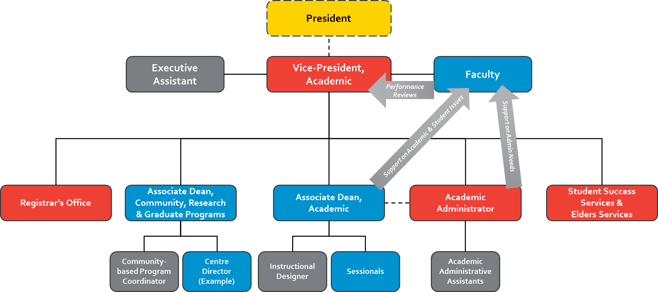

VICE-PRESIDENT, ACADEMIC
Under the direction of the President, the Vice-President, Academic provides leadership for the academic mission of the institution with a view to ensuring student success and academic excellence within a culturally inclusive First Nations environment. The Vice-President, Academic plays a leading role in the

development and implementation of strategic direction for the University and oversees the functioning of all academic units on all campuses including faculty labour relations, community-based programs, instructional delivery systems and research collaborations. A more detailed role description is included in the Appendix.

ASSOCIATE DEAN, ACADEMIC
Under the direction of the Vice-President Academic, the Associate Dean, Academic will work in coordination with the Vice-President to provide leadership in the University’s academic work, having responsibility for general academic program development and approval, teaching development, sessional labour relations, and liaison with academic programs and other campuses. The Associate Dean, Academic works in close collaboration with the Academic Administrator and faculty to ensure quality delivery and effective operation of the academic activities at the University and resolution of student matters. A more detailed role description is included in the Appendix.

ASSOCIATE DEAN, COMMUNITY, RESEARCH & GRADUATE PROGRAMS
Under the direction of the Vice-President, Academic, the Associate Dean, Community, Research & Graduate Programs will work in coordination with the Vice-President to provide leadership in the University’s community-based programs and strategic research pursuits. This Associate Dean will develop, oversee and facilitate matters pertaining to community-based programs, working closely with communities to develop and deliver programs to accommodate their needs for learning. In addition, this Associate Dean will work with University leadership and faculty to promote and plan collaborative research activities of benefit to First Nations communities in Saskatchewan and beyond, including pursuing funding opportunities and establishing Centres to effectively deliver on positive research outcomes. A more detailed role description is included in the Appendix.

PROGRAM COORDINATOR
Under the direction of the Associate Dean, Academic, the Program Coordinator is the appointed faculty representative of a Program who provides program expertise in support of academic planning and associated budgeting and scheduling, and program development and renewal. The Program Coordinator chairs their respective Program Council, facilitating planning requirements and decision recommendations on behalf of their Program Council with the Associate Dean, Academic and Vice-President, Academic. The Program Coordinator leverages their program knowledge to work collaboratively with the Associate Dean, Academic regarding academic hiring in their area and student inquiries/requests and works with academic leadership and Student Success Services on student recruitment initiatives for their area. A more detailed role description is included in the Appendix.

ACADEMIC ADMINISTRATOR
Under the direction of the Vice-President, Academic, the Academic Administrator works in close collaboration with the Associate Dean, Academic to ensure effective and efficient operation of the academic activities of the University in support of meeting student needs. The Academic Administrator oversees and facilitates effective administrative execution of various academic policies and procedures in support of the Associate Dean, Academic and faculty including academic planning and scheduling, budget development and management, sessional hiring, exam scheduling and room booking, course evaluations, purchasing and inventory management, student management and leave requests. The Academic Administrator provides oversight of the Academic Administrative Assistants and delegates duties and responsibilities in support of effective and efficient delivery of academic duties. A more detailed role description is included in the Appendix.

REGISTRAR’S OFFICE
The First Nations University of Canada’s Office of the Registrar is the source of information and advice on academic rules, regulations and degree requirements. The Registrar is responsible for directing and coordinating all administrative processes relevant to the student’s academic standing and career; provide

leadership to dedicated staff in the areas of student systems, admissions, registration & records. As a member of the University’s management team, collaborating on approaches to long- and short-term planning that is student focused. The Registrar is responsible for instituting best practices with respect to all of the University’s registrarial functions and developing strategies to ensure the University is prepared to meet the goals of our institutional strategic plan.

For detailed information or advice pertaining to academic rules, regulations, or degree requirements please refer to our Academic Calendar or contact the Registrar’s Office.

STUDENT SUCCESS SERVICES & ELDER SERVICES
The Student Success Services & Elders Services department provides a network of supports for students while they progress through their academic journey. Services and support include recruiting, academic and retention advising, access to Elder supports and counselling, subject tutoring and writing support. Academic and retention staff engage and build relationships with students while helping them navigate the university experience. Staff consider students' needs, interests and academic goals and assist them in academic program planning and accessing services. Elders and knowledge keepers provide students with personal, cultural and spiritual guidance while sharing traditional knowledge in programs, classes, traditional activities and ceremonies.

Student Success Services nurtures a student success culture using leading initiatives, programs, facilities and functions on a university wide basis. Such a culture needs to focus on the student holistically, be pervasive and integrated across all academic and academic support areas, incorporate contemporary student development theory and practice, and transform the student environment at FNUniv into a highly engaged one with significant measurable growth in student success.

Decision Making & Responsibility Summary
The following visual shows the governance bodies that are involved with strategic academic decisions and issues and the roles involved with dealing with day-to-day academic administration decisions and issues.
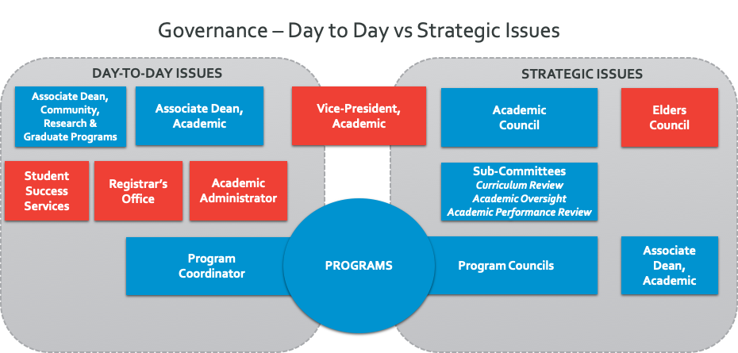

All academic administration is centrally delivered to allow faculty to focus on teaching and research outcomes. Academic administration is delivered in accordance to all the terms and articles of the Collective Bargaining Agreements.

The following table provides a summary of who is involved with and their level of responsibility related to key strategic decisions involved with academic delivery. Academic administration responsibilities related to the Associate Dean, Community, Research & Graduate Programs is related to delivery of community-based programming.

STRATEGIC DECISIONS | Program Council | Associate Dean, Academic | Associate Dean, Community, Research & Graduate Pgms | Academic Council | Vice-President, Academic
Annual Academic Budget |  |  |  |  | Recommend1
Annual Faculty Academic Plan & Budget | Recommend | Review & Recommend | Review & Recommend |  | Approve
Business Case | Submit | Review & Recommend | Review & Recommend |  | Approve
Program Quality/ Maintenance/ Creation | Recommend | Input | Input | Approve2
Distance Delivery – Technology Enhancements | Recommend | Review & Recommend | Review & Recommend | Review & Recommend | Recommend3
Program Accreditation (i.e. INSW, ENHS) | Submit | Input | Input |  | Recommend4
Program Curriculum Creation / Revisions | Recommend | Input |  | Approve
Community-Based Programming | Recommend |  | Recommend |  | Approve
Faculty Hiring | Recommend | Input | Input |  | Recommend5
Faculty Budget Oversight | Recommend | Input | Input |  | Approve
Academic Policies & Procedures | Recommend | Recommend | Recommend | Approve6
Administrative Policies & Procedures |  |  |  |  | Recommend7

- Annual Academic Budget requires recommendation from Vice-President, Finance & Administration and then approvals from President & Board of Governors.
- All approvals by FNUniv bodies are, in cases dealing with academic issues related to students and programs, internal approvals that require submission to relevant U of R academic units in adherence to the Federated Agreement.
- If Academic Strategy requires incremental budget, it must go to Vice-President, Finance & Administration for review and recommendation to the President and then Board of Governors for approval.
- Accreditation is recommended to appropriate governing accreditation body for approval.
- VP Academic recommends hire to the President after credentials are approved by the U of R Associate Vice-President
- Final authority to approve policies is the Board of Governors
- Administrative Policies approved by the Board of Governors and Procedures are approved by the President

Final – January 22, 2020

The following table provides a summary of who is involved with and their level of responsibility related to key day-to- day decisions involved with academic administration. Academic administration responsibilities related to the Associate Dean, Community, Research & Graduate Programs is related to delivery of community-based programming.

DAY-TO-DAY DECISIONS | Program Coordinator | Academic Administrator | Associate Dean, Academic | Associate Dean, Community, Research & Graduate Pgms | Vice-President, Academic
Academic Scheduling (Drawn from Academic Plan) |  | Administer with Registrar | Review & Recommend | Review & Recommend | Approve
Course Changes | Submit | Administer with Registrar | Review & Recommend | Review & Recommend | Approve
Sessional / Lab Instructors / TAs Hiring | Recommend | Administer | Approve | Approve
Contracts |  |  | Approve | Approve8
Incremental Budget Requests | Recommend | Administer | Input | Input | Recommend
Distance Education Delivery (Online) | Advise |  | Recommend | Recommend | Approve
Community-Based Program Delivery | Recommend |  |  | Approve
Performance Reviews for Faculty |  |  | Review (APRC) |  | Approve
Performance Reviews for Sessionals | Recommend |  | Review | Review | Approve
Student Management | Advise | Administer with Registrar | Approve | Approve
Exam Scheduling | Recommend | Administer with Registrar | Approve | Approve
Room Scheduling |  | Administer with Registrar
Purchase Requests (Travel, PD, Other) | Submit | Process | Approve | Approve
Hiring Administrative Support Staff |  | Recommend |  |  | Approve
Grades |  |  |  |  | Approve
Leave Requests |  | Process | Review & Recommend | Review & Recommend | Approve
Collective Agreements Matters | Support | Support | Support | Support | Approve

8 Academic program contracts with external entities require the U of R’s approval

FNUniv Academic Governance & Administration Framework Page | 15

SECTION 2:

TERMS OF REFERENCE FOR ACADEMIC GOVERNANCE BODIES

ACADEMIC COUNCIL TERMS OF REFERENCE

DUTIES & POWERS
The Academic Council shall have the following duties and powers:

  - The Academic Council shall have the power over all decisions affecting academic programs including admissions, content, graduation requirements/standards, and related policies and procedures;
  - The Academic Council shall exercise its powers and duties on academic matters in a manner consistent with the mission of the First Nations University of Canada;
  - The Academic Council shall ensure academic and administrative compatibility with its agreements with its federated partners, the University of Regina;
  - The Academic Council shall review from time to time all aspects of the academic work of First Nations University of Canada and make appropriate recommendations to the President and the Board of Governors;
  - The Academic Council shall consider and approve any academic plans, including but not restricted to all proposals for the establishment and discontinuation of courses, programs, academic departments, and centers;
  - The Academic Council shall approve general library and archival policy proposals;
  - The Academic Council shall, every three years, appoint a faculty representative to the Board of Governors, consistent with the First Nations University Act; That representative will solicit faculty input to be approved by the Academic Council at a meeting in advance of, and for delivery to, the Board of Governors’ quarterly meetings; and
  - The Academic Council may appoint sub-committees as it deems appropriate to carry out its responsibilities in an effective manner; The Academic Council will approve terms of reference and membership of sub-committees; Membership need not be limited to members of Academic Council, and may include those with special expertise, including Elders.

ACADEMIC COUNCIL MEMBERSHIP
  - Members are those permanent, tenure track and term members holding academic rank at the First Nations University of Canada including: Lecturers, Assistant Professors, Associate Professors, Full Professors, Librarians, Laboratory Instructors, Associate Deans, Directors and Vice-President, Academic;
  - Three Academic Council seats will be available to FNUniv sessionals. Representation from all three campuses will be sought but is not required. The three sessional representatives shall be full voting members of the Academic Council. Following the new CBA, URFA will inform sessionals at the beginning of every term of existing committee vacancies (including membership to this committee);
  - The following positions will have ex officio membership on Academic Council: the Academic Administrator, the Registrar and the Director of Student Success Services; and
  - Elders and student representatives from the student association may participate in Academic Council

upon invitation; however, they will not have voting privileges.

THE CHAIR OF ACADEMIC COUNCIL
  - The Vice-President, Academic will be the Chair of Academic Council and instances where required, Co-Chair is the Associate Dean, Academic;
  - The Chair will be responsible for convening and chairing of the Academic Council meetings; and
  - The Chair will ensure the minutes are maintained and disseminated by sub-committees and by the Academic Council.

ACADEMIC COUNCIL MEETING
  - The Academic Council will meet at least four times a year, twice in the fall semester and twice in the winter semester;
  - Special meetings may be called, provided there is notice of at least five working days;
  - Special meetings of the Academic Council may be called by petition of at least 25% of the membership. The Chair will call such a meeting within 10 days of receiving the petition;
  - Notices of meetings shall be circulated in advance along with copies of the minutes from previous meeting and the agenda; and
  - The agenda shall be amended and adopted as the first order of business after calling the Academic Council meeting open.

QUORUM
  - No meeting of the Academic Council can start, and no business conducted, unless there is a quorum. The quorum shall be 25% of the members of Academic Council;
  - The minutes of the meetings shall indicate who is present, and business will be opened by the Chair or designate declaring that a quorum has been reached;
  - Business of the Academic Council, once begun, may continue until it is determined, by recount at a member’s request, that there is no longer a quorum; and
  - Participation in meetings includes by video conferencing and/or teleconference.

VOTING
  - Votes, other than for elected positions or amendments of these terms of reference, may ordinarily be taken, and decisions made, by a duly convened Academic Council meeting;
  - Notice of meeting to consider the matter to be voted on shall be announced in advance, or the matter may be voted on by a secret ballot of the membership;
  - Any member of the Academic Council may request a secret ballot of the entire membership on any matter for decision; this request shall be recorded in the minutes, and a secret ballot on the matter will be held. The vote shall be held promptly;
  - Votes may be held by electronic ballot provided the process ensures one-member, one vote, and that the secrecy of the ballot is ensured; and

  - Votes shall ensure that members have at least 5 working days to cast a ballot electronically.

AMENDMENT TO THE TERMS OF REFERENCE
These Terms of Reference may be changed by secret ballot of the entire membership, in which 2/3 of those voting agree to the proposed change as long as the proposed change is in accordance with the policies and regulations of the First Nations University of Canada including the federated agreement with the University of Regina.

ADOPTION OF THE TERMS OF REFERENCE
These Terms of Reference will come into force upon adoption by a majority of the members of Academic Council voting by secret ballot.

Approved by Academic Council on November, 22, 2019

CURRICULUM REVIEW COMMITTEE TERMS OF REFERENCE
- PURPOSE & RESPONSIBILITIES
The Curriculum Review Committee is a sub-committee of Academic Council. In coordination with the relevant University of Regina academic unit, the Curriculum Review Committee is responsible for reviewing and recommending to Academic Council new programs, courses and changes to existing programs/courses at FNUniv.

COMPOSITION & TERMS OF SERVICE
The CRC is comprised of a Program Coordinator from each FNUniv Program area, resulting in 10 voting members. The Associate Dean, Academic and the Registrar are ex-officio members of the CRC. CRC Members that are Program Coordinators are designated terms consistent with their appointments.

The Vice President, Academic will then be responsible for filling the vacant positions.

LEADERSHIP
  - The Associate Dean, Academic will serve as Chair.
  - The Registrar is available for administrative support for the Chair of the CRC. Support includes collecting agenda items, circulating agenda items, collecting data, attending and taking minutes at each CRC meeting.

VOTING
Decisions require a majority vote (50% +1) at the beginning of the meeting. In order for quorum, 6 voting members must be in attendance.

FREQUENCY OF MEETINGS:
The Committee will meet quarterly, in advance of Academic Council meetings.

COMMITTEE ON ACADEMIC OVERSIGHT TERMS OF REFERENCE

PURPOSE & RESPONSIBILITIES
The Committee on Academic Oversight is a sub-committee of Academic Council charged with making recommendations to Academic Council on matters that involve internal FNUniv processes. In particular, it shall, for the FNUniv and in consultation with Program Councils, develop proposals for the establishment and continuous review of academic processes, procedure statements and structures. The Committee will work within the parameters of the Federated Agreement with the University of Regina to ensure no overlap or misunderstanding occurs for students, faculty and sessional lecturers.

The primary responsibilities of the Committee on Academic Oversight are:
to establish academic policies and processes and monitor their implementation.

Limits to scope of the Committee on Academic Oversight include:
  - The Committee on Academic Oversight will be limited to the academic operations at the FNUniv. Policies regarding admission, registration, etc. that are already codified in the University of Regina Academic Calendar are outside of the scope of this Committee.

COMPOSITION & TERMS OF SERVICE
The composition of the Committee on Academic Oversight includes:
  - 2 Senior Staff (Associate Dean, Academic and Associate Dean, Community, Research & Graduate Programs)
  - 3 Faculty Representatives
  - 3 Staff Representatives (Academic Administrator, Director of Student Success Services and the Registrar)
  - 1 Staff Support (Senior Analyst)

Terms of service for administrative committee members will be continuous, including for the Associate Deans, the Academic Administrator, the Director of Student Success Services, the Registrar and the Senior Analyst.

Terms of service for non-administrative committee members will be set for a period of 1 to 3 years.

LEADERSHIP
  - The Associate Dean, Community, Research & Graduate Programs will serve as Chair.
  - A Faculty Representative will serve as Vice Chair.
  - The FNUniv Board of Governors will be final approving authority for all academic policies that are recommended from this committee.

VOTING
Decisions require a majority vote (50% +1). In order for quorum, 4 voting members must be in attendance at the beginning of the meeting.

FREQUENCY OF MEETINGS:
The Committee will meet quarterly, in advance of Academic Council meetings.

ACADEMIC PERFORMANCE REVIEW COMMITTEE TERMS OF REFERENCE

COPIED FROM COLLECTIVE AGREEMENT

- THE ACADEMIC PERFORMANCE REVIEW COMMITTEE

  - The Academic Performance Review Committee, whose function is to formulate recommendations to the Vice-President (Academic) regarding career development, is to consist of four members of the academic staff elected by members of the academic staff. Academic staff members with permanent appointments at or above the rank of Assistant Professor are entitled to serve on the Committee. The Faculty Association shall be advised of the membership of the committee.
  - Academic Council and the Vice-President (Academic) shall constitute the Committee that calls for nominations and oversees the election.
  - Members of the Committee will sit for one or two years, with terms staggered to provide two newly elected members each year. Elections will be conducted to provide, in addition to the four principal members, an alternate member who may be called to serve when necessary.
  - The Committee will elect its own Chair, who may vote if votes are taken and who will also deal with the matter of an alternate Committee member as necessary. The normal procedure for the Committee will be consensus, although members should be free to record dissenting opinions.
  - Members of the Committee will respect the requirement for confidentiality in the Collective Agreement. Members of the Committee will respect the provision of Article 2 of the Collective Agreement.
  - The Committee will have access to the complete documentation pertaining to the individuals to be reviewed as set out in Article 19.
  - A Committee member shall neither sit nor vote when candidates for whom he or she prepared recommendations are considered or there is another conflict of interest in which case the Chair shall call upon the alternate member. If votes are taken, voting shall be by secret ballot.
  - A University Elder shall be invited to be present at every meeting of the Academic Performance Review Committee.
  - The Committee shall meet with candidates and Department Heads upon the request of these individuals. The Committee may invite candidates and Department Heads to meet with it.
  - Nothing in this Appendix shall be construed as requiring an academic staff member to appear before the Academic Performance Review Committee.
  - Nothing in this Appendix shall be construed as precluding an academic staff member from enlisting the aid of the Faculty Association or the Canadian Association of University Teachers.
  - In accordance with the provisions of article 19.2.1.3, prior to decisions being made by the Vice- President (Academic), the academic staff member shall see the recommendations and be provided with an opportunity to comment on the recommendations and discuss with the Vice-President (Academic).

PROGRAM COUNCIL TERMS OF REFERENCE
ProgramCouncils are comprised of academic members from each FNUniv program area (see Section 1.5 for further information on Academic Program Structure). Program Councils are led through collegial governance, planning and decision making, supported by an appointed Program Coordinator (faculty member) to facilitate recommendations to FNUniv academic administration roles and the appropriate governing bodies.

PURPOSE & RESPONSIBILITES
Each of the following FNUniv Programs are led by a Program Council to ensure collegial governance, planning and decision making:

  - Indigenous Business & Public Administration
  - Indigenous Communication & Fine Arts
  - Indigenous Education
  - Indigenous Health
  - Indigenous Languages
  - Indigenous Literatures in English
  - Indigenous Social Work
  - Indigenous Studies
  - Indigenous Knowledge & Science

Program Councils are responsible for recommendations within their Program regarding each annual academic plan and budget; new business cases; program quality, maintenance and creation; technology enhancements for distance delivery; program and curriculum creation and revisions; community-based programming requirements; faculty hiring and Program budget oversight.

COMPOSITION & TERMS OF SERVICE
Program Council members are those permanent, tenure track and term faculty members holding academic rank at FNUniv in a particular Program area including: Lecturers, Assistant Professors, Associate Professors, Full Professors and Laboratory Instructors.

The Associate Dean, Academic and Associate Dean, Community, Research & Graduate Programs sit on Program Councils as ex-officio members.

Membership terms are continuous as long as a member maintains academic rank at the FNUniv.

LEADERSHIP & COORDINATION
  - The members of a Program Council will elect a Program Coordinator to be Chair and represent the Program in facilitating recommendations to Academic Council or the appropriate sub-committee, as well as provide advice and support to the Senior Academic Management Team on day-to-day academic operational matters. A Program Coordinator serves for a 3-year term.
  - Sitting on the Program Council as ex-officio members, the Associate Deans will share information with Program Councils on broader FNUniv academic delivery matters, put forth strategic items for discussion and identify potential collaboration opportunities and ideas with other Programs, and provide advice as appropriate regarding academic planning and delivery discussions with the Program Council members.

  - Recommendations are provided to the appropriate Associate Dean for review and recommendation to Academic Council or the Vice-President, Academic depending on the decision. For further information, see Section 1.7 - Decision Making & Responsibility Summary.

VOTING
Decisions require a majority vote (50% +1). In order for quorum, there must be a majority of voting members in attendance at the beginning of the meeting.

FREQUENCY OF MEETINGS
The Committee will meet quarterly, in advance of Academic Council meetings.

ELDERS COUNCIL TERMS OF REFERENCE

PURPOSE
The First Nations University of Canada Elders Council is established by the Act Respecting the Saskatchewan Indian Federated College 2001 and mandated by the First Nations University of Canada to promote unity of member First Nations through the promotion and preservation of Indigenous heritage, knowledge, culture, values, and customs.

The purpose of the Elders Council is to enhance the quality of life, and to preserve, protect, and interpret the history, language, culture, and artistic heritage of First Nations. The Elders Council will:

  - identify, validate, promote, and protect Indigenous Peoples’ knowledge of spiritual and physical resources;
  - assist First Nations University of Canada’s faculty, students, and staff and First Nations in the revival and re-institution of their spiritual heritage, knowledge, culture, customs, and traditions;
  - act as advisors regarding Indigenous knowledge and spiritual practices and protocol as the stabilizing influence in First Nations society;
  - support and advise in the holistic educational pursuits which promote transmission of heritage for First Nations communities;
  - monitor and advise on activities of researchers and scholarly institutions regarding indigenous cultural and intellectual property;
  - act as advisors, guidance personnel and spiritual leaders for departments and organizations within the First Nations University of Canada; and
  - be role models for First Nations and Canadian society.
The Elders Council will work to advance the strategic priorities of the First Nations University of Canada in a holistic manner.

ROLES & RESPONSIBILITIES
The Role of an Elder is to:

- Share and render First Nations ceremonial protocols and prayers for the Board meetings and FNUniv events and/or gatherings;

- Provide guidance and assistance on matters related to spiritual laws, values, cultural practices and ceremonial protocols;

- Provide advice and teachings related to ancestral and Indigenous knowledge, heritage and histories;

- Share teachings on traditional related governance, leadership and guidance on Indigenous laws and their spiritual foundations;

- Share teachings and knowledge on the spiritual foundations of Inherent and Treaty rights; and

- Maintain community worldviews and protocols for the enhancement and preservation of Indigenous knowledge and languages; and

- Advise on activities of researchers and scholarly institutions regarding indigenous cultural and intellectual property.
Roles specific to FNUniv include:

  - In-class support person
  - Cultural instructor
  - Advise faculty on course creation and development
  - Instruct and/or co-instruct courses

MEMBERSHIP
The Elders Council is made up of Elders that are recognized by their respective communities as having knowledge and understanding of the traditional culture of the community, including the physical manifestation of the culture of the people their spiritual and social traditions. The three campuses of Regina, Saskatoon and Prince Albert of the First Nations University of Canada will each have representatives in the Elders Council.

  - Elder: An Elder is any person recognized by a First Nations’ community as having knowledge and understanding of the traditional culture of the community, including the physical manifestation of the culture of the people their spiritual and social traditions. Knowledge and wisdom, coupled with the recognition and respect of the people of the community, are the essential defining characteristics of an Elder. Some Elders have additional attributes, such as those of traditional healer9.
  - Elder’s Helper (oskàpèwis): A person who assists an Elder in ceremonies, offers cultural teachings, or assist with other necessary services.
  - Traditional Knowledge Keeper: A person who is not an Elder, however provides a cultural role and is held in high regard as a knowledge keeper.

MEETINGS
  - The Elders Council shall meet four times a year in alignment with the four seasons.
  - Special meetings may be called by the President or Vice President, Academic.
  - The Director of Student Success Services will preside as Chair of the meetings.
  - The Chair will be responsible for coordinating meetings and creating the agenda.

AMENDMENT TO THE TERMS OF REFERENCE
The Terms of Reference may be changed in accordance with policies and regulations of the First Nations University of Canada.

Approved by Elders Council on November, 23, 2019

9 This definition is from the Saskatchewan Indian Cultural Centre. It can be accessed at https://sicc.sk.ca/elder-faqs/

SENIOR ACADEMIC MANAGEMENT TEAM TERMS OF REFERENCE

PURPOSE & RESPONSIBILITES
The Senior Academic Management Team (SAMT) collaborates to ensure delivery of FNUniv’s institutional academic plan in accordance with the budget, through effective and efficient academic administration to achieve student outcomes. Primary responsibilities include:

  - Discussing and addressing academic planning and scheduling matters;
  - Supporting development of and management of the academic budget;
  - Discussing and addressing matters of academic delivery and administration;
  - Discussing and addressing student matters;
  - Strategizing on continuous improvement opportunities;
  - Facilitating communication among the academic delivery team; and
  - Identify and mitigating areas of academic risk.

COMPOSITION
The SAMT is comprised of:
  - Vice-President, Academic (Chair)
  - Associate Dean, Academic
  - Associate Dean, Community, Research & Graduate Programs
  - Academic Administrator
  - Registrar
  - Director of Student Success Services.

LEADERSHIP & COORDINATION
  - The Vice-President, Academic chairs the SAMT.
  - The Academic Administrator provides meeting preparation and coordination support to the Chair.
  - All members will be required to prepare agenda items in advance as required to ensure productive meeting discussions.

FREQUENCY OF MEETINGS
The SAMT will meet on a monthly basis. Additional meetings are called by the Vice-President, Academic as necessary.

SECTION 3:

ACADEMIC ADMINISTRATION ROLE DESCRIPTIONS

VICE-PRESIDENT, ACADEMIC – ROLE DESCRIPTION

POSITION SUMMARY:
Under the supervision of the President, the Vice-President, Academic provides leadership for the academic mission of the institution with a view to ensuring student success and academic excellence within a culturally inclusive First Nations environment. The Vice-President, Academic plays a leading role in the development and implementation of strategic direction for the University and oversees the functioning of all academic units on all campuses, community-based programs and instructional delivery systems.

REPORTS TO:
President of First Nations University of Canada

PRIMARY DUTIES & RESPONSIBILITIES:

    - Maintain, develop and enhance the quality of academic instruction and education at the First Nations University of Canada, consistent with the University’s strategic plan;
    - Participate in long-term academic planning and development, and in special projects undertaken by the University;
    - Promote strategic partnership development with First Nations communities and other post- secondary institutions;
    - Plan, organize, and direct academic activities in close consultation with the President, Associate Deans, Program Councils and Coordinators, Registrar, Student Success Services, Librarians and with academic leaders at the University of Regina and other partner institutions.
    - Ensure balanced participation by faculty in teaching, research and service areas, including service to the University and service to Indigenous communities;
    - Encourage effective participation and involvement of Elders and Traditional Knowledge Holders in all aspects of academic affairs of the University;
    - Plan, organize and coordinate academic planning, program development, curriculum, program review evaluations in conjunction with the Associate Deans, Program Councils, Program Coordinators, the Academic Council, faculty, Elders and First Nations communities, organizations and governments;
    - Participate in the recruitment and selection of academic staff and recommend faculty appointments to the President;
    - Participate in the recruitment and selection of Associate Deans, Program Coordinators, Academic Administrator, Registrar, Director, Student Success Services and Librarians, and provide leadership, direction, supervision, and performance management for those positions;
    - Provide leadership for the academic performance review process and render decisions in accordance with the faculty collective bargaining agreements;
    - Ensure compliance of academic processes with University of Regina by-laws and regulations, and with collective bargaining agreements;
    - Serve as a resource to the Board of Governors; as required by the President
    - Represent the University on committees at the University of Regina, other post-secondary institutions, First Nations Institutions and other bodies as directed by the President;

    - Other related duties as required.

MINIMUM EDUCATION REQUIREMENTS:
The holder of this position must have a PhD from a recognized university, plus a minimum of five years of experience in teaching and research at the university level. In addition, the rank of Assistant Professor is required.

MINIMUM WORK EXPERIENCE REQUIRED:
This position requires a minimum of five years of senior academic experience at a university.

ESSENTIAL SKILLS REQUIRED:

  - Knowledge of Indigenous cultures, values and traditions.
  - Ability to create and implement strategic direction for an academic institution.
  - Ability to provide executive leadership to the university community in coordination with the President.
  - Ability to make high-level decisions under pressure and in compliance with institutional policies, academic regulations, and other applicable legislative or governing frameworks, such as collective agreements.
  - Ability to promote appropriate collegial governance.
  - Knowledge of academic program development and approvals.
  - Ability to build partnerships with other academic institutions, communities, governments and other organizations.
  - Personnel management experience, including performance review and recruitment of faculty and staff.
  - Financial management experience.
  - Excellent oral and written communication skills.

WORKING CONDITIONS:

  - Physical & Sensory Demands: Minimal demands typical of a senior leadership position operating within an office environment.
  - Working Environment: Minimal exposure to disagreeable conditions typical of a senior leadership position exposed to stress and pressure associated with senior level responsibilities.

SCOPE:

- Direct Supervisory: Associate Dean, Academic; Associate Dean, Community, Research & Graduate Programs; Academic Administrator; Registrar; Director, Student Success Services; Librarian; Executive Assistant, Academic
- Indirect Supervisory: All staff from the areas as outlined above in the absence of their direct supervisors
- The Vice-President, Academic plays a critical leadership role in the overall management and strategic direction of the institution.
- The Vice-President, Academic is responsible for ensuring that students receive a high quality post- secondary education in a culturally appropriate, positive learning environment.
- The Vice-President, Academic promotes collegial governance and decision-making in conjunction with Academic Council, Program Councils and other appropriate committees and academic bodies.

- The Vice-President, Academic represents the institution as its academic leader at external meetings and events.

KEY COMPETENCIES:
Inclusiveness Strategic Planning Managing People Emotional Intelligence
Stewardship and Managing Resources Problem Solving / Decision Making Communication
Quality Improvement Leadership Teamwork
Service Focus

ASSOCIATE DEAN, ACADEMIC – ROLE DESCRIPTION

POSITION SUMMARY:
Under the direction of the Vice-President, Academic, the Associate Dean, Academic will work in coordination with the Vice-President to provide leadership in the University’s academic work, having responsibility for general academic program development and approval, teaching development, sessional labour relations, and liaison with Program Councils, communities and other campuses, including developing and supporting distance education. The Associate Dean, Academic works in close collaboration with the Academic Administrator and faculty to ensure quality delivery and effective operation of the academic activities at the University and resolution of student matters. The Associate Dean, Academic will work with the Executive, Program Coordinators, Directors, Coordinators, faculty, students and community stakeholders.

REPORTS TO:
Vice-President, Academic

PRIMARY DUTIES & RESPONSIBILITIES:

    - Promote the overall mission of the University with respect to First Nations cultural enhancement and First Nations self-determination initiatives through education in accordance with established policies and regulations of the First Nations University of Canada;
    - Provide clear and concise reports on activities to the Vice-President, Academic regularly;
    - Inform Senior Management about academic activities as appropriate;
    - Provide innovative, flexible leadership to the University faculty and staff;
    - Be knowledgeable of Aboriginal customs, philosophical traditions, and ceremonial etiquette;
    - Consult with Elders to obtain their guidance in matters pertaining to local traditional cultural values and ceremonial protocol;
    - Ensure that Elders are consulted and present at all appropriate meetings.
    - Develop relationships and maintain effective communications with the community, campuses, and academic units;
    - Play a lead role in student academic misconduct investigations.
    - Coordinate hiring to ensure adequate staffing and advise new sessionals, lab instructors and teaching assistants in their career development;
    - Supervise academic staff members including scrutinizing and approving travel, miscellaneous claims and professional development forms, as well as approving and scheduling annual leave;
    - Complete the annual performance review process for academic staff members;
    - Attend Academic Council and Chair the Curriculum Review Committee;
    - Work with Program Councils & their elected Program Coordinators to ensure the effective operation of the academic activities of the University;
    - Develop, coordinate, and administer the review and process for the introduction of all new academic courses/programs and for the revision of existing courses/programs;
    - Creating and time-tabling classes

    - Approving grade rosters and grade change forms
    - Coordinate and administer distance educations programs and offerings;
    - Ensuring compliance with academic administration policies and procedures;
    - Coordinate and negotiate with Human Resources regarding any sessional Collective Agreement matters.

MINIMUM REQUIREMENTS:
Tenured academic staff member with a strong record in research, teaching, and service.

MINIMUM WORK EXPERIENCE REQUIRED:
This position requires a minimum of five years’ experience in academic administration at a senior level. Strong record in teaching, research, community service, work with Elders and Aboriginal communities.

ESSENTIAL SKILLS REQUIRED:

- Knowledge of best practices in academic environments; curriculum development, management, and program assessment; program planning; instructional design and development, including technology enhanced methods of course delivery; and trends in general education.
- Ability to provide strategic recommendations to the Senior Administration regarding the academic mission of the University.
- Demonstrated knowledge of organizational structure, workflow, and operating procedures.
- Ability to understand and work in a flexible environment, working well under time pressures with simultaneous activities.
- Ability to work collegially and collaboratively with a wide range of people.
- Excellent written and oral communication skills.
- Proficient in the use of research, statistical analysis, and information technologies.
- Proven ability to provide sustained leadership in a dynamic and rapidly changing environment.
- Ability to work under pressure and meet deadlines.
- Demonstrated planning, implementation and negotiation skills.
- Superior interpersonal and community relation skills and the ability to communicate effectively within a diverse community.
- An understanding of the contexts (political, cultural, academic) within which FNUniv operates;
- Ability to speak a First Nations language would be an asset.
- Knowledge of First Nations cultures, values and traditions is essential.

WORKING CONDITIONS:

- Physical & Sensory Demands: Minimal demands typical of a senior leadership position operating within an office environment.
- Working Environment: Minimal exposure to disagreeable conditions typical of a senior leadership position exposed to stress and pressure associated with senior level responsibilities.

SCOPE:

- Direct Supervisory: Instructional Designer
- Indirect Supervisory: In absence of the Vice-President, Academic, the Academic Administrator; Registrar; and Librarian

- The Associate Dean, Academic plays a critic leadership role in the overall management, strategic direction and delivery of academic programming at the institution.
- The Associate Dean, Academic is responsible for ensuring that students receive a high quality post- secondary education in a culturally appropriate, positive learning environment.
- The Associate Dean, Academic promotes collegial governance and decision-making working closely with the Program Councils, Academic Council and other appropriate committees and academic bodies.
- The Associate Dean, Academic represents the institution as its academic leader at external meetings and events.

KEY COMPETENCIES:
Inclusiveness Strategic Planning Managing People Emotional Intelligence
Stewardship and Managing Resources Problem Solving / Decision Making Negotiation Skills
Communication Quality Improvement Leadership Teamwork
Service Focus

ASSOCIATE DEAN, COMMUNITY, RESEARCH & GRADUATE PROGRAMS – ROLE DESCRIPTION

POSITION SUMMARY:
Under the direction of the Vice-President, Academic, the Associate Dean, Community, Research & Graduate Programs will work in coordination with the Vice-President to provide leadership in the University’s community-based programs and graduate programs and strategic research pursuits. The Associate Dean will support the Associate Dean, Academic as required for general academic program development and approval, teaching development, and liaison with Program Councils, communities and other campuses. This Associate Dean will develop, oversee and facilitate matters pertaining to community- based programs, working closely with communities to develop and deliver programs to accommodate their needs for learning. In addition, this Associate Dean will work with University leadership and faculty to promote and plan collaborative research activities of benefit to First Nations communities in Saskatchewan and beyond, including pursuing funding opportunities and establishing Centres to effectively deliver on positive research outcomesThe Associate Dean, Community, Research & Graduate Programs will work with the Executive, Program Coordinators, Directors, Coordinators, faculty, students and community stakeholders.

REPORTS TO:
Vice-President, Academic

PRIMARY DUTIES & RESPONSIBILITIES:

    - Promote the overall mission of the University with respect to First Nations cultural enhancement and First Nations self-determination initiatives through education in accordance with established policies and regulations of the First Nations University of Canada;
    - Provide clear and concise reports on activities to the Vice-President, Academic regularly;
    - Inform Senior Management about academic activities as appropriate;
    - Provide innovative, flexible leadership to the University faculty and staff;
    - Promote research activities and seek funding to benefit to First Nations communities in Saskatchewan and beyond, facilitating establishment of research collaborations and centres as required to advance and showcase FNUniv’s research pursuits;
    - Be knowledgeable of Aboriginal customs, philosophical traditions, and ceremonial etiquette;
    - Consult with Elders to obtain their guidance in matters pertaining to local traditional cultural values and ceremonial protocol;
    - Ensure that Elders are consulted and present at all appropriate meetings.
    - Develop relationships and maintain effective communications with the community, campuses, and academic units;
    - Support the Associate Dean, Academic as required in working with Program Councils & their elected Program Coordinators to ensure the effective operation of the academic activities of the University;
    - Administer, oversee, and facilitate matters pertaining to community-based programs including receiving applications from communities for programming needs, working with the Community-based Program Coordinator and Program Councils to determine capacity to deliver, modes of delivery and program content, and review and refine annual community-based program plan; and

    - Oversee planning and operation of Graduate programs, including collaborating with Program Coordinators and Councils on their intended plans, liaising with other partner institutions as required, and ensuring all components in place to deliver.

MINIMUM EDUCATION REQUIREMENTS:
Tenure-track or tenured academic staff member with a strong record in research, teaching, and service.

MINIMUM WORK EXPERIENCE REQUIRED:
This position requires a minimum of five years’ experience in academic administration at a senior level. Strong record in teaching, research, community service, work with Elders and Aboriginal communities.

ESSENTIAL SKILLS REQUIRED:

- Knowledge of best practices in academic environments; curriculum development, management, and program assessment; program planning; instructional design and development, including technology enhanced methods of course delivery; and trends in general education.
- Knowledge of best practices related to institutional research, including research administration, grant applications process, ethics review, and trends in indigenous research.
- Ability to provide strategic leadership and advice to the Senior Administration regarding the academic and research mission of the University.
- Demonstrated knowledge of organizational structure, workflow, and operating procedures.
- Ability to understand and work in a flexible environment, working well under time pressures with simultaneous activities.
- Ability to work collegially and collaboratively with a wide range of people.
- Excellent written and oral communication skills.
- Proficient in the use of research, statistical analysis, and information technologies.
- Proven ability to provide sustained leadership in a dynamic and rapidly changing environment.
- Ability to work under pressure and meet deadlines.
- Demonstrated planning, implementation and negotiation skills.
- Superior interpersonal and community relation skills and the ability to communicate effectively within a diverse community.
- An understanding of the contexts (political, cultural, academic) within which FNUniv operates;
- Ability to speak a First Nations language would be an asset.
- Knowledge of First Nations cultures, values and traditions is essential.

WORKING CONDITIONS:

- Physical & Sensory Demands: Minimal demands typical of a senior leadership position operating within an office environment.
- Working Environment: Minimal exposure to disagreeable conditions typical of a senior leadership position exposed to stress and pressure associated with senior level responsibilities.

SCOPE:

      - Direct Supervisory: Community-based Program Coordinator and Directors of any established research centres.
      - Indirect Supervisory: In absence of the Vice-President, Academic, the Director, Student Success Services and the Executive Assistant to VP.

      - The Associate Dean, Community, Research & Graduate Programs plays a critic leadership role in the overall management, strategic direction and delivery of community and graduate programming and research pursuits at the institution.
      - The Associate Dean, Community, Research & Graduate Programs is responsible for ensuring that students receive a high quality post-secondary education in a culturally appropriate, positive learning environment, as it relates to community-based and graduate programs.
      - The Associate Dean, Community, Research & Graduate Programs promotes collegial governance and decision-making working closely with the Program Councils, Academic Council and other appropriate committees and academic bodies.
      - The Associate Dean, Community, Research & Graduate Programs represents the institution as its academic leader at external meetings and events.

KEY COMPETENCIES:
Inclusiveness Strategic Planning Managing People Emotional Intelligence
Stewardship and Managing Resources Problem Solving / Decision Making Negotiation Skills
Communication Quality Improvement Leadership Teamwork
Service Focus

PROGRAM COORDINATOR – ROLE DESCRIPTION

POSITION SUMMARY:
Under the direction of the Associate Dean, Academic, the Program Coordinator is the appointed faculty representative of a program who supports collegial governance, planning and decision making as initiated by individual Program Councils. The Program Coordinator is recommended by the Program Council and appointed by the Vice-President, Academic as per the Collective Agreement. The Program Coordinator provides program expertise in support of student management, academic planning and associated budgeting and scheduling, and program development and renewal. The Program Coordinator chairs their respective Program Council, facilitating planning requirements and decision recommendations on behalf of their Program Council with the Associate Dean, Academic and the Vice-President, Academic. The Program Coordinator leverages their program knowledge to provide advice to the Associate Dean, Academic regarding academic hiring in their area and student inquiries/requests and works with academic leadership and Student Success Services on student recruitment initiatives for their area.

REPORTS TO:
Associate Dean, Academic Program Council

PRIMARY DUTIES & RESPONSIBILITIES:

    - Chair their Program Council, calling and facilitating quarterly meetings;
    - Work with their Program Council to develop their annual academic program plan and budget;
    - Work with the Associate Dean, Academic and Academic Administrator on time-tabling and exam scheduling;
    - Participate in the admission process, including reviewing applications for admission, establishment of selection committee and review dates, etc. (if required);
    - Review course enrolments in program area;
    - Provide advice to the Associate Dean, Academic on hiring of sessionals, teaching assistants and faculty in the program area;
    - Responsible for representing their program area with all FNUniv and U of R academic approvals, including membership on the FNUniv Curriculum Review Committee.
    - Program coordinators will be responsible to review sessional academic instructors (per SASM).
    - Facilitate discussion with Program Council on academic strategy, program maintenance, program / course creation or changes, technology, curriculum creation and revisions, etc. and provides recommendations to the Associate Dean, Academic;
    - Participate in any accreditation processes (if applicable);
    - Provide leadership on student recruitment in program area, in collaboration with Student Success Services;
    - Support Program Council with budget oversight to ensure management of program academic delivery within approved budget;
    - Submit incremental budget requests for program through the business case approach;
    - Provide advice to the Associate Dean, Community, Research & Graduate Programs regarding community-based programming delivery and associated requirements to ensure integrity of quality delivery for students;
    - Provide advice to the Associate Dean, Academic regarding student management requests (i.e. overload, exception, etc.) and respond to student concerns as required;
    - Mentor faculty in the program area regarding teaching and research;
    - Support the Vice-President, Academic as required regarding any faculty and sessional Collective Agreement matters.

ACADEMIC ADMINISTRATOR – ROLE DESCRIPTION

POSITION SUMMARY:
Under the direction of the Vice-President, Academic, the Academic Administrator works in close collaboration with the Associate Dean, Academic to ensure effective and efficient operation of the academic activities of the University in support of meeting student needs. The Academic Administrator oversees and facilitates effective administrative execution of various academic policies and procedures in support of the Associate Dean, Academic and faculty. The Academic Administrator provides oversight of the Academic Administrative Assistants and delegates duties and responsibilities in support of effective and efficient delivery of academic duties.

REPORTS TO:
Vice-President, Academic

PRIMARY DUTIES & RESPONSIBILITIES:
including and scheduling, budget development and management, sessional hiring, exam scheduling and room booking, course evaluations, purchasing and inventory management, student management and leave requests

    - Support Vice-President, Academic and Associate Deans in preparing annual academic plan and budget through consolidation of program plans and budgets through submissions from Program Coordinators;
    - Develop and implement academic administration policies and procedures to ensure effective and efficient academic administration support within the institution;
    - Provide advice and respond to inquiries and concerns of academic faculty and staff regarding academic administration processes and procedures;
    - Administer the academic scheduling process in coordination with the Registrar’s Office, providing information requirements to the Registrar as per academic plan as well as course changes once scheduled, based on appropriate academic leadership approvals;
    - Monitor academic budget, ensuring program spending is within approved budgets;
    - Receive and assess incremental budget requests from faculty and provide to academic leadership for input and approvals;
    - Receive student inquiries and requests, working with Program Coordinators, the Registrar and academic leadership to assess and obtain approvals;
    - Coordinate exam and room scheduling through the Registrar’s Office, based on recommendations from Program Coordinators and as approved by academic leadership;
    - Support Associate Deans in coordination of hiring for academic staff members and providing orientation as required on administrative processes, working closely with support of HR;
    - Process various requests from faculty and academic staff (i.e. travel, professional development, leave, purchase, other miscellaneous) and obtain approvals from academic leadership as required;
    - Interview and select new administrative support staff in collaboration with Human Resources, as approved by the Vice-President, Academic;
    - Oversee, mentor and manage academic administration staff, including delegation of administrative responsibilities to meet the needs of the institution and ensure efficient and effective delivery and

responsiveness;
    - Guide and support faculty performance review process as required by the Vice-President, Academic and Associate Deans;
    - Support the Vice-President, Academic as required regarding Collective Agreements matters; and
    - Provide administrative support to Vice-President, Academic for monthly Senior Academic Management Team meetings.

MINIMUM JOB REQUIREMENTS:
This position requires a two (2) year diploma in Office Administration, Business or related field with a minimum requirement of ten (10) years’ experience in academic administration.

WORKING CONDITIONS:

- Physical & Sensory Demands: Minimal demands typical of an administration position operating within an office environment.
- Working Environment: Minimal exposure to disagreeable conditions typical of a management position exposed to stress and pressure associated with management level responsibilities.

SCOPE:

- Direct Supervisory: Academic Administrative Assistants
- Indirect Supervisory: Program Coordinators (to ensure they submit required plans, budgets, response to inquiries, etc. in accordance with established timelines);
- The Academic Administrator plays a critical management role in ensuring effective and efficient administration of academic programming delivery within the institution, through collaboration with academic leadership, faculty and staff.

KEY COMPETENCIES:
Inclusiveness Budget Management Office Administration
Office Technology & Software Academic Policies & Procedures
Detail Oriented & Disciplined Organization Timeliness
Managing People
Stewardship and Managing Resources Problem Solving
Communication Teamwork Service Focus

SECTION 4:

KEY ACADEMIC ADMINISTRATION POLICIES & PROCEDURES

Introduction

Annual Academic Plan & Budget Development
Category: xxx
Number: xxx
Audience: xxx
Issued: xxx
Reapproved: xxx
Owner: xxx
Approved by: xxx
Contact: xxx

Teaching & Learning is the foundation of a transformative education experience. The annual First Nations University of Canada institutional academic plan provides a detailed and accurate overview for what is expected for the delivery of FNUniv academic programs for that academic year in alignment with budget. The purpose of this policy is to develop and implement a consistent, transparent and accurate academic plan and associated Program budgets which guides academic operations and administration for that year.

Policy

PLANNING APPROACH:
Annual and long-range planning is critical to the proper functioning of the institution and the ability of the institution to provide programs which fulfil the needs of the communities and students which FNUniv serves. Annual academic plans are essential to guide the academic operations of the institution.

Because of the nature of academic operations, it is recognized that such planning involves the need for flexibility in the allocation of resources, consistent with fair treatment of academic staff members and in accordance with the provisions of the collective agreements. As such, academic and long-range planning is conducted in consultation with faculty.

Academic planning will be undertaken in a spirit of collegiality, with open communication consistent with First Nations values.

PLAN CONTENT:
The institutional academic plan is derived based on consolidating individual program plans and budgets. Annual academic program plans and budgets, as developed by the Program Councils, include detailed course information and budget required for Year 1, as well as projected course schedule for Year 2 to

support longer term planning and U of R scheduling requirements. The annual program plan is based on a standard template which includes the following content:

YEAR 1:
    - Program’s Strategic Objectives: Strategic objectives in alignment with advancing FNUniv’s mission
    - Academic Staffing Plan: Faculty teaching loads, new tenure track / term positions, sabbaticals, leaves, reduced time / course relief, stipends
    - Academic Year Schedule: Course offerings by semester with identification of faculty or sessional instruction, required stipendiary appointments, maximum enrolment, delivery methods and number of credit hours for all undergraduate and graduate courses
    - Academic Other:
      - Other Hiring: Projected number of teaching assistants, lab instructors, guest lecturers, student support, field supervisors and practicum supervisors with the associated cost for each for the fiscal year (April 1 to March 31)
      - Field Trips: Projected number of field trips for related courses and associated cost for fiscal year with brief plan outlined
    - Instructional Supplies & Other Resources: List of instructional supplies or services needed for the fiscal year and any additional equipment requirements required from Information Technology Services; Plant, Property & Maintenance; or Finance
    - Culture Camp: Outline the number of culture camps and the cost per culture camp for the fiscal year
    - Other Requirements & Costs: List of faculty conferences, employee travel, practicum travel with the rationale and associated cost for each
    - Future Changes: Anticipated program or staffing changes after budget year
    - Business Case(s): If additional positions are required as part of this plan, a business case must be attached.

YEAR 2:
    - Projected Course Schedule: Projected course offerings by semester

REVIEW & APPROVAL:
Annual program academic plans and budgets are recommended by Program Councils and submitted to the Associate Deans for review and recommendation to the Vice-President, Academic for final approval.

The budget approval process is separate to this and requires review and approvals in conjunction with the Vice-President, Finance & Administration, President and Board of Governors.

TIMELINES:
The following provides a high-level overview of key timelines as it relates to academic plan and Program budget development:

DATE | OCCURRENCE
By September 15 | Academic planning kickoff meeting led by Vice-President, Academic
Before September 30 | Student Success Services meets with Associate Deans to share summary of student needs as input into academic planning
By October 1 | Budget sheets including mandate will be sent to the Associate Deans as input for the academic Program plan and budget development  process

Month of October | Meetings between Associate Deans, Program Coordinators and Program Councils
By November 8 | Initial draft of Program Academic Plans & Budgets to Associate Deans
November 15 | Revised draft of Program Academic Plans & Budgets to Associate Deans
November 22 | Consolidated institutional Academic Plan & Budget to Vice-President, Academic
November 30 | Consolidated Academic Budget and associated business cases submitted to Finance
December 15 | Consolidated budget review complete
December 31 | Approval of consolidated budget by President
January 15 | Deadline for preparation of submission to the Board of Governors
Last weekend of January | Consolidated budget presented to the Board of Governors for approval
February 28 | Approved budgets sent out to Faculties

Role and Responsibilities

VICE-PRESIDENT ACADEMIC (OWNER)
    - Provide planning and budget parameters to Associate Deans and Program Councils; and
    - Final review and approval of institutional academic plan.
    - Recommend budget for approval to President and Vice-President, Finance

ASSOCIATE DEAN ACADEMIC (COMPLIANCE)
    - Provide input to various Program Councils during development of their annual program plans;
    - Review program plans and provide feedback for refinement as required; and
    - Work with the Academic Administrator and other Associate Dean to consolidate annual institutional academic plan and submit to Vice-President, Academic for approval.

ASSOCIATE DEAN COMMUNITY, RESEARCH & GRADUATE PROGRAMS (COMPLIANCE)
    - Provides input to various Program Councils as it relates to graduate programs during development of their annual program plans;
    - Provides input to the Community-based Program Coordinator during development of the community- based programs annual plan, including liaising with communities and Program Councils as required to determine capacity to deliver, modes of delivery and program content;
    - Review program plans with graduate courses and community-based program annual plan and provide feedback for refinement as required;
    - Work with the Academic Administrator and other Associate Dean to consolidate annual institutional academic plan and submit to Vice-President, Academic for approval.

PROGRAM COORDINATOR (COMPLIANCE)
    - Work with their Program Council to develop their annual academic plan and Program budget and submit to the Associate Dean Academic for review.

COMMUNITY-BASED PROGRAM COORDINATOR (COMPLIANCE)
    - Work with communities and associated Program Councils to develop the annual community-based program plan and program budget and submit to the Associate Dean, Community, Research & Graduate Programs for review.

ACADEMIC ADMINISTRATOR (COMPLIANCE)
    - Issue call to Program Coordinators annually with timeline requirements for annual plan and Program budget submissions; and
    - Support Associate Deans in consolidating all Program plans and budgets into the annual institutional academic plan and budget.

Consequences for Noncompliance
Academic planning is essential to provide a detailed and accurate overview of what is expected for delivery of academic programs along with staffing and financial requirements. Timely submission of academic plans is critical to feed into the budget process and meet University of Regina scheduling requirements and associated deadlines.

In addition, operating deficits lead to financial distress and must be avoided. Therefore, a balanced financial projection is mandatory and strict adherence to budget limits during the year will be enforced subject to the overall performance of the University.

Noncompliance by any employee may result in disciplinary action.

Process
The following process map demonstrates the key steps involved with execution of this policy:

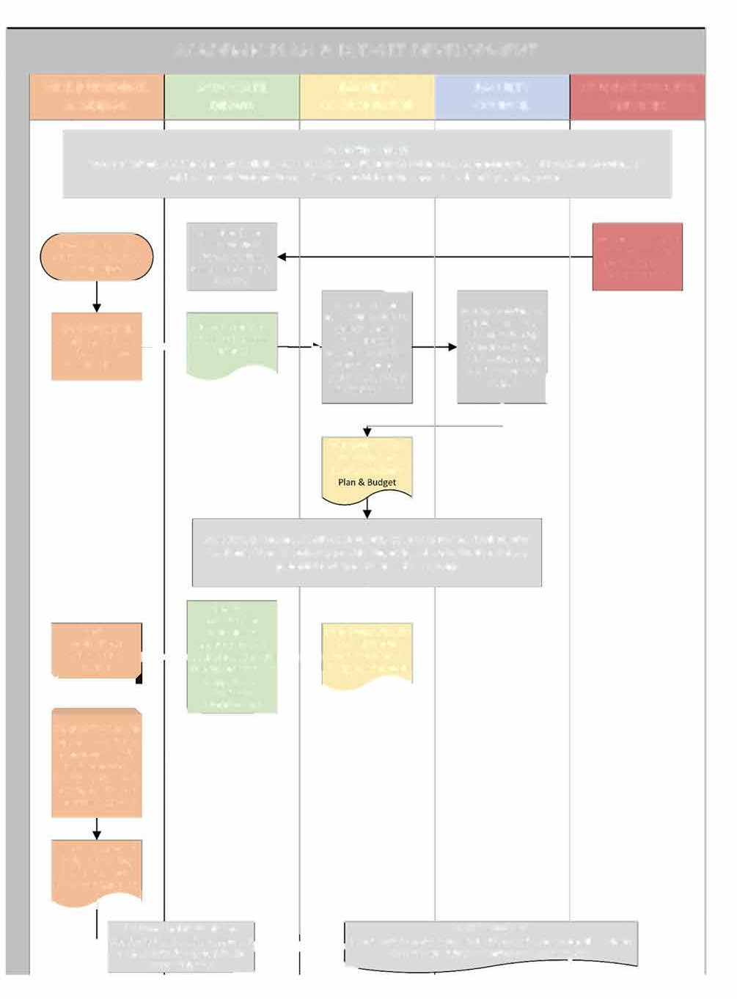ACADEMIC PLAN & BUDGET DEVELOPMENT

VICE-PRESIDENT, ACADEMIC

ASSOCIATE DEANS

PRO'RAM COORDINATOR

PRO'RAM COUNCIL
STUDENT SUCCESS SERVICES

BY SEPTEMBER 15
V!ce-P5e9!de.;, Acade,!c ,ee;9 C"<h ;he A992c!a=e Dea-9, P52g5a, C226d!.a<269, C2,,A.!;D-ba9ed P52g6a, C227d!.a;25 a-d D!5ec;26 2f S<Ade-; SAcce:: Se5B#ce: >2 )!c)2ff ?he a./Aa* acade,$c 4*a0.!.g 452ce::

);lJ;m P1bd n;1\'b A81:;UJ8 &N1V 1b 41b;
JV@Y_U1dFYV

BY OCTOBER 1
S'1@V&: UZ&1W,':V1fS;.'dY'XS Y_•la.I ..
AbbY7H1f; D;1Wb
BY SEPTEMBER 30
AbbY8G1d; %;1Vb
:''T `/T- SSS UE
W;d;i:scbu?Yssa sAt8u3d:e;nUt F8 &O1WWHVB

R(#'/]' B[%,'V
S-''WS & Ma@&aU'
*EM Y(aM
�

AbbY8F1d; D;1Vb
CEEN&/@aUEOS VE 'P Z1a1U;d;]b. IVFfF1f;
S-aM' ![&,'V
H6a@@/@, IMF#'SS
aY@V& Sb.dha:M;'VSeSVS;0@;J:Zb V

BY NOVEMBER 8
"VFdF1P :^1<f Y<
Fa#\6Ub A#a&'=0#

PME,Ma: CEEM&0AaTEN
=18FPHd1g;b U;;gFVBb
`0T. U-'/N PME,Ma< CE[@#57 UE &1S#ZSS
a@& &'^'6EI Fa#Z8Vb A#a&'</# P7a@ & B\&,'U

&_;[1_; bhUU1\n Y= bgh:;Vd W;;:b dY
Z_YlF:; JWZhe AY_ A83:;UF8 &R1V

A:93c!a<e Dea.: ,ee; C!;h eac P52g5a, C2A-c!* <2 5eB%eC d5af< FacA*<D Acade,&c P*a1: & BAdge<:; 482B&de: '.4A< ba:ed 2- &.:<&<A<&2.a* B&eC; 42<e.<!a* 5eB!:(2-9 d!:c@:9ed a: a g52@4

*;8;Hl;b FVbfKfifJYV1P

D;l;SYZb 8YVbYSF:1f;:
JVbdFdhdFYW1P
&
BY NOVE MBER 15
R'_4S'& Fa#\6Vb
A81:B;hU9FB8;&gS1V & 1-•2-+--r BAk:81B:;d;T41J8b;(:Q1YVW 1SS !<1◄◄·-�1 A81:;UF8 &P1Vb &

BY NOVEMBER 30
AIJME^'S A#a&'<2#
P6BakB:; MB';#dEf>Y ?+J'8;@q&S
'^;bJ:;Vg, FW1V8; &
A&</@, PM'S3&'@U &
BEaP& +GM aIINE]a6

*;8;Fl;b 1ZZ_Yl;: BZ&,'U & *Z@&/C, "aS'& E@ BEaM&/ PNE]/ F'& aJKNE^a9S
0c *;8;Fl; !FV1P A81:;UJ8 (P1W & Bh:B;f; hb;: 1b a;?;a;V8; gCaYkBCYjf
!18hSfo bj5UJbbKYWb
(SZAJ8I1:E;MVU'&F8!b
�
A:UFVJbf]1dY_)
B[&,'TS S[!;/UT'&

*;lHbFYVb 1V: >LX1PFp1fLYW Y?
A81:;UJ8 &S1W 61b;: YW 1ZZaYl;:
�I
I-- .,,/, , $
BY FEBRUARY 28

BZ&,'T c&D1*Z`;@&m/@Mg,E(c/+d1Q'A?L[0N'&-);

Related Information
Annual Academic Plan & Budget Template
b)aN +ER S#-)&Z6/@,, )a)#[U0E@ <a@a,'<)DT, )V#.
#

Introduction

Academic Scheduling
Category: xxx
Number: xxx
Audience: xxx
Issued: xxx
Reapproved: xxx
Owner: xxx
Approved by: xxx
Contact: xxx

As part of FNUniv’s Teaching & Learning strategic process highlighted in the Strategic Plan, the institution will facilitate effective and efficient program and operational administration. This relates to Academic Scheduling which involves timetabling courses as per execution of the approved annual Academic Plan to maximize efficient utilization of classroom space.

Policy

ALIGNMENT WITH ACADEMIC PLAN & BUDGET:
Resulting from the approved Academic Plan and Budget, Academic Scheduling initiates the execution of this plan by timetabling the specified courses for each Program area for each semester (Spring/Summer, Fall, Winter). Any changes to course offerings require review and approval as per academic governance structure.

INTEGRATION WITH UNIVERSITY OF REGINA:
FNUniv is integrated within the University of Regina’s established process for scheduling, which requires use of the Scheduling software’s Data Collection Utility (DCU) and adhering to defined timelines for course scheduling for each semester. This information is outlined in the University of Regina’s Class Scheduling Policy number OPS-040-015. The following policy provisions are excerpts from this U of R policy:
Students should be able to take courses needed to graduate from their program in a timely manner.
•
INTRODUCTION:
An effective class schedule is one that facilitates learning, maximizes access for students within the constraints of classroom space and the number of instructional hours available, and accommodates a range of pedagogies. In developing the course schedule for students and instructors, the following goals must be balanced:

    - Classes should be scheduled to avoid as many course conflicts as possible.
    - Classes should be scheduled to make the best possible use of the available space for teaching and learning activities.
    - Class schedules should consider the pedagogical needs of courses and programs.
    - Instructors should be able to obtain schedules that permit them to integrate their professional duties of teaching, research and service in a reasonable way.
    - In scheduling classes, the University must, if requested to do so, make accommodations under the provincial Human Rights legislation.
    - Scheduling priorities should be scheduled equitably across all disciplines.

The purpose of this policy is to:

- define university policy as to the use and management of classroom space;
- establish and enumerate processes for allocating classroom space; and
- encourage the university community to make efficient and coordinated use of classroom space.

DEFINITIONS:

    - Classroom Space – is a university resource allocated to and managed by the Scheduling area of the Registrar’s Office. All academic units share access to classroom space to deliver courses
    - Core/Required Courses – Those courses a student must take in order to graduate from their
program of study.
    - Daytime hours – Classes with start times between the hours of 08:30 and 16:59.
    - Evening hours –Classes with start times between the hours of 17:00 and 22:00.
    - Forced Meeting Day and Time – A class that has been forced in the system to be scheduled on a specific day and/or time.
    - Standard Meeting Pattern – An established pattern of class meeting times.
    - Tier 1 Accommodation – A Tier 1 accommodation is an approved workplace accommodation or some other contractual obligation that the University has with a faculty member.
    - Tier 2 Arrangement – A request for an arrangement that does not fall into the definition of a Tier 1 Accommodation request.

FNUNIV POLICY PRIORITIES:
FNUniv is focused on maximizing the efficiency of classroom utilization and scheduling process, through adherence to established priorities and clear criteria for justifiable accommodations. It is expected that each faculty member adheres to accommodation definitions and only advance justifiable accommodations (i.e. Tier 1 Accommodation or Tier 2 Arrangement) forward for change approvals. Stronger adherence at the faculty level will minimize non-justifiable requests coming forward for approval which adds inefficiencies and unnecessary changes to the overall scheduling process.

Classroom Space
Scheduled classroom space is a university resource allocated to and managed by the Registrar’s Office. All academic units share access to classroom spaces to deliver courses.

Classroom allocation and specifications (i.e. square footage, video equipment, computer lab, etc.) is managed by PPM with information provided to the Registrar’s Office to ensure classroom allocations and

specifications are recorded in the DCU accordingly. Classroom space will not be removed from the classroom pool unless formally approved by the Vice-President, Finance & Administration.

Casual bookings of classroom space not in use for purpose of events, meetings, tutorials, workshops, etc. must be booked through the Registrar’s Office to ensure it does not conflict with scheduled classes and labs.

Changes to room allocation after the timetable is produced must be approved by the Associate Dean, Academic and the Vice-President, Academic.

Standard Meeting Patterns
Standard meeting patterns will be used when scheduling most classes. A complete list of standard meeting patterns can be found in Appendix 1 outlined in the University of Regina’s Class Scheduling Policy number OPS-040-015.

Non-standard Meeting Patterns
There may be some classes that need to be scheduled outside of standard meeting patterns (a one-week intensive course for example). In these cases, forced entries to the system may be used.

Tier 1 Accommodation Requests
A tier 1 accommodation will be made for employees who have a temporary or permanent medical disability or who have a contracted teaching agreement to teach on a specific day and/or time. Tier 1 accommodation requests will be respected 100% of the time. Tier 1 accommodation requests are made to the Associate Dean, Academic through the Academic Administrator, with a note to Human Resources.

Tier 2 Arrangement Requests
Reasonable efforts will be made to honor Tier 2 arrangement requests (i.e. administrative work, research work), but the arrangement might not be guaranteed as the scheduling needs of the students will take precedence. Tier 2 arrangement requests are made to the Associate Dean, Academic through the Academic Administrator. These requests are not always accommodated or approved.

Schedule Requirements and Deadlines
Designated academic administration staff are required to enter all pertinent information into the established timetabling system by the approved deadline dates.

Role and Responsibilities

REGISTRAR’S OFFICE (OWNER)
    - Distributes call for timetable to Associate Deans & Academic Administrator to kickoff scheduling process, along with various timelines associated with UofR DCU steps and deadlines;
    - Enters all pertinent scheduling data into the DCU system by the approved deadline dates based on the schedule spreadsheet document provided by the Academic Administrator;
    - Informs Academic Administrator and Associate Deans when draft timetable is available for review;
    - Works with Academic Administrator to resolve changes to schedule based on University of Regina Class Scheduling Policy (OPS-040-015);
    - Receives and forwards Course Add/Revision/Cancellation Forms to UofR after schedule has been published; and
    - Overall responsibility for maintaining this policy, including distributing and educating on updates.

FACULTY MEMBER OR INSTRUCTOR (COMPLIANCE)
    - Submits justifiable accommodations (i.e. Tier 1 Accommodation or Tier 2 Arrangement) requests to the Academic Administrator for approval by the Associate Dean, Academic.

ACADEMIC ADMINISTRATOR (COMPLIANCE)
    - With support as required from Academic Administrative Assistants, prepares detailed course requirements in spreadsheet for courses specified in Academic Plan;
    - Receives course change requests from faculty members, sessionals and instructors and provides to Associate Dean for approval;
    - Works with Associate Deans to finalize schedule and submits to Registrar’s Office;
    - Works with Registrar to resolve changes to schedule based on University of Regina Class Scheduling Policy (OPS-040-015); and
    - Ensures Course Add / Revision / Cancellation Forms (with support from Academic Administrative Assistants) are completed as requested by the Associate Deans and obtains appropriate approvals from Associate Deans (for Add and Cancellation) or Vice-President, Academic (for Revision) and submits to Registrar’s Office.

ASSOCIATE DEAN, ACADEMIC
    - Reviews and refines schedule as developed by the Academic Administrator from the Academic Plan information;
    - Reviews draft schedule from the Course Schedule Detail Audit Report extracted from CASPUR during Program Review period, consults with Program Coordinators and provides required changes based on faculty/sessional/instructor customization and student needs to Academic Administrator.
    - Consults with Program Coordinators on course revisions, additions or cancellations identified after the schedule is published, working with the Academic Administrator to complete required forms and approvals.

PROGRAM COORDINATOR
    - Coordinates Program Council meetings to prepare Academic Plan; and
    - Reviews draft schedule during Program Review period, consults with faculty and sessionals and recommends changes to Academic Administrator.

VICE PRESIDENT, ACADEMIC
    - Reviews course revisions and provide approvals for justifiable requests.

Consequences for Noncompliance
Noncompliance with this policy could result in unnecessary delays in the time a student takes to complete a program, or other consequences that could impact the class schedule in a negative way.

Processes

GENERAL APPROACH:
Based on the “Year 2 Projected Courses” in the approved Academic Plan, the Academic Administrator (supported by the Academic Administrative Assistants) works alongside the Associate Deans to specify for each course to be offered – the type (i.e. lecture, lab, online), meeting pattern, the need for particular room type and requested times for which instructors are unavailable to teach. It must also be identified which courses must be scheduled in a conflict-free manner (which may include courses from other Faculties) as well as identifying course combinations (more information below). This information is provided to the Registrar’s Office to input into the DCU software, ensuring all special requirements of the course are included.

    - For course combinations, the Academic Administrator (supported by the Academic Administrative Assistants) must ensure that course combinations are reviewed and modified. The student demand for courses (as determined by the Student Counts in the course combinations) must not exceed the number of seats available in the components of the courses.
    - Any courses from the course combinations that are not being offered get deleted automatically. Course combinations drive the entire scheduling system. It may be prudent to discuss students’ course needs with Program Coordinators and to reflect these in course combinations and number of seats scheduled. The Registrar’s Office can provide further guide on course combination requirements.

Following the preliminary deadline of DCU data input, the Academic Administrator, supported by the Academic Administrative Assistants, will review the overall timetable to ensure timetabling conflicts are minimized and to catch any errors that may have happened during data entry. Requests may be made to the Registrar to move specific courses to solve conflict problems.

COURSE ADDITIONS / REVISIONS / CANCELLATIONS:
Once the timetable is created, class changes are made by completing course add or revisions forms to make changes to the schedule based on justifiable Tier 1 Accommodations or Tier 2 Arrangements. The forms must be submitted to the Registrar’s Office. If a day or time change is required for a class, the request must be approved by the Associate Dean, Academic and the Vice President, Academic. Class adds, enrollment changes, classroom changes, and any other changes require the Associate Dean, Academic’s approval. The changes are submitted to the U of R Registrar’s Office for processing prior to the CRN creation to reduce the number of revisions to the timetable in Banner, resulting in fewer inaccuracies and omissions as per past process. Changes following the timetable being published are to be minimized.

REVIEW & APPROVAL:
Scheduling is administered by the Academic Administrator in collaboration with the Registrar’s Office. All timetabled courses require review and approval of the Associate Dean, Academic and approval of the Vice- President, Academic for day and time changes of classes.

LOW-ENROLMENT CLASSES:
The Registrar’s Office provides information to the Senior Academic Management Team (SAMT) regarding classes with low-enrolment. SAMT will review and discuss low-enrolment classes and engage with Program Coordinators concerning such classes to understand if cancellation will result in undue hardship for students who need them to graduate. Cancellation of a low-enrolment class required approval of the Vice-President, Academic.

The following process map demonstrates the key steps involved with execution of this policy:

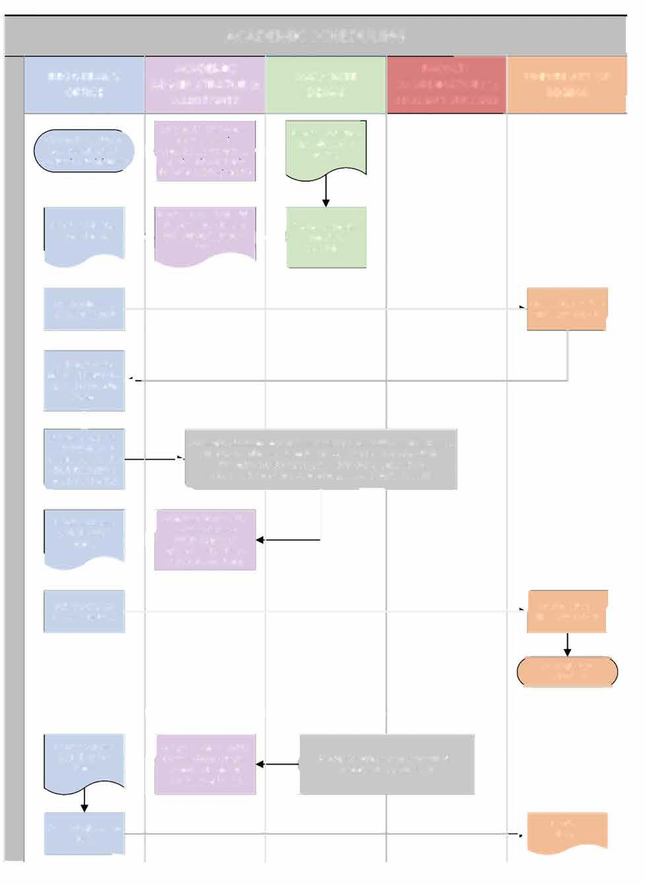ACADEMIC SCHEDULING

REGISTRAR'S ACADEMIC ASSOCIATE
OFFICE ADMINISTRATOR & DEANS
0ROGRAM COORDINATORS &

UNIVERSITY OF REGINA

C,MM 5^c $>S4n,-L4 m^
ASSISTANTS

Prepare detailed course "404>x4k #0<42tM4
requirements m #`d4,2k<44m 5]c
STUDENT SUCCESS

Alk^0?,o4 D4,Wk & } k`g4,2k=44o 5^g 0^rek4k re#ie&
l
Academic Adminis ra or k`40@5>42 1U A0,24SA0
!M,U ('+4,c 2 !g^140q42")

"404Bx4k g4x>k42 #0<42tM4
"404>x4k #0<42rN4 9g^S Akk^0>,o4 D4,Uk; Re$ie& and refine

,
k`g4,2k=44n f+- L- 7^fy,g2k n^ "4:>kog,f'k �- #0=42rM4

EVn4ck #0=42rL4
24o,CMk DUo] ocu
95D04

k`g4,2k=44o

- Cg4,o4k 5>gln 2g,7o ^6
$ET4m,-L4 DW ocu I

"4;>kng,j'k 78H/4 FU7^gT42 DC& Fk g4- opened for Faculty
�
Review
+
Informs Academic Academic Adminis ra or facili a es re%ie' process (i!h Associa!e Deans,
•

A2S>W>kng,o^g & Akk_>,o4 D4,Xk o<,n
�
Recei%es Co"rse I C^T`L4n4 C^rck4 A22/
F,0sOn| C^^g2DY,o^ck & #nt24Uo #t004kk #4gxD04k n^ g4xD4{ 2g,7o
$FT4n,.P4 >V DC'; >Z`ro ;,o<4g42 7^g 0=,W;4k (-,k42 ^[

2c,7o $FT4o,-L4 Fk c4,2| 9^g xD4zDV:
accommodation/ arrangemen req"ests and s !den needs)

A22/ "4x>kD^V
F^gTk
�
,_

#r.SFok C=,U;4
-o,>V A`ag^x,Mk (9g^T Akl^/H,o4 D4,V
,W2/^g *!, A0,24T>0)
"4xGk>^V F^hSk &

L FFW,M n{4,Kk p^

"4bs4knk n^ (^7"
%JT4o,-L4 FW ocu I
FCW,L #0<42uM4
!v.LFk<42

IFADDI#IONAL CHANGE" IDEN#IFIED A�I#E! "CHED$LE I" %BLI"HED (***CHANGE" "HO$LD BE MINIMI&ED):
r
Recei#es Co"rse iC^S`Q4o4k C^wgk4 A22/
l

A22/ "4x>kF ^V "4x>k>^\ F^gT; -o,DVk
F^gTk Akk^1>,o4 D4,U/ *!
!g^:g,S C^^i2FU,o^ck 0^WkrLn zIn= o<4 Akk^1J,o4 D4,W, A/,34S>/

)^8"
A0,24SF0 ,``g^x,R l

Related Information
University of Regina Class Scheduling Policy - https://www.uregina.ca/policy/browse-policy/policy-OPS- 040-015.html

University of Regina DCU Timetabling Timelines

Course Offerings Timetabling Information Spreadsheet Template Course Add / Revision Form

Introduction

Hiring Academic Staff (Non-Faculty)
Category: xxx
Number: xxx
Audience: xxx
Issued: xxx
Reapproved: xxx
Owner: xxx
Approved by: xxx
Contact: xxx

Teaching & Learning and Student Success are two strategic processes highlighted in the Strategic Plan to set the foundation of a transformative education experience and ensure academic and career success for all students. As such, faculty and academic staff play an integral role in delivering on these strategic processes. FNUniv may contract with Sessional Lecturers, Teaching Assistants, Lab Instructors, Guest Lecturers, Student Support (Tutors and Invigilators), Field Supervisors and Practicum Supervisors to ensure the required resource capacity to deliver on the institutional academic plan.

Policy

GENERAL:
All Sessional Academic Staff appointments shall be made by FNUniv after teaching duties have been assigned to faculty academic staff members and in consideration of recommendations from the appropriate Program Coordinator and Associate Deans, and appropriate budget approval.Work in the bargaining unit will be assigned following the process of internal and external posting. All offers will be made in writing (normally via electronic e-mail), with a copy to the Faculty Association. Appointment of sessional lecturers requires prior approval of recommended candidates’ academic qualifications from the Univeristy of Regina.

INDIGENOUS PRIORITY:
In accordance with Article 5 – Affirming Diversity in the 2017-2019 Sessional Academic Staff Members Agreement priority is to be given to qualified First Nations and other Indigenous candidates when posting and making appointments for Sessional Academic Staff positions. Sessional positions may be offered to qualified First Nations and other Indigenous applicants on a priority basis.

PRE-POSTING OFFERS:
In advance of Sessional Academic Staff positions being posted, Sessional including out-of-scope persons who have taught the course(s) in question at least three times, will be contacted by Human Resources by e- mail to determine whether they are interested in teaching one or more sections of the course. These e-mails

will be copied to the Faculty Association. The Sessional Instructor will have seven (7) days from the date on which the e-mail was sent to respond to the offer, indicating their acceptance of the offer to teach the course(s), and their desired sections. If more than one applicant desires the same section, the considerations outlined in Section 17.7 of the Academic Staff Members Agreement will apply.

POSTING NOTICES:
If a Sessional Academic Staff position is not filled through the process outlined above, it will be posted in two stages: internally, for a period of two (2) weeks; then, if the position has not been filled, externally, for a period two (2) weeks.

TIMING & CONTENT OF POSTINGS:
Job postings shall be posted at least three months before the beginning of the semester to which they apply. All internal job postings shall be posted on the first business day of the month; the closing date for receipt of applications shall be the fourteenth day of the same month. All external job postings shall be posted within ten (10) business days thereafter.

Each job posting shall include the qualifications, type of position, course number, title, location, delivery mode, anticipated enrolment, salary range, TA support, start and end date of the contract, day and time of the course (where these are known), a commitment to equity in hiring in accordance with the provisions of Article 4 – Affirming Diversity, and a statement that this is a unionized position.

HIRING TIMELINES PER SEMESTER:
The following table provides deadlines for hiring steps by semester:

 | Hiring Step |  | For Fall |  | For Winter |  | For Spring/Summer
Associate Dean consults with HR on hiring needs |  | Early March |  | Early September |  | Early January
HR sends Pre-Posting Offers (if applicable) |  | Mid-March |  | By Mid-September |  | By Mid-January
Initial assignment of courses from Pre-  Posting Offers by Associate Dean |  | By End of March |  | By End of September |  | By End of January
Unassigned positions advertised internally |  | 1st Business Day in April |  | 1st Business Day in October |  | 1st Business Day in February
Unassigned positions advertised externally |  | Within 10 days of Internal Post Closing |  | Within 10 days of Internal Post Closing |  | Within 10 days of Internal Post Closing
All positions assigned |  | By End of May |  | By Early November |  | By Mid-March
Contracts completed |  | By End of June |  | By Mid-November |  | By End of March

CREATION OF NEW INSTRUCTOR ACCOUNTS:
Creation of new instructor accounts should be completed as soon as a new instructor or sessional is hired. See associated procedure 4.3.1 Account Creations.

Role and Responsibilities

ASSOCIATE DEAN ACADEMIC (OWNER)
    - Consults with Human Resources on requirements for sessionals to deliver on Academic Plan for semester;
    - Reviews any accepted Pre-Posting Offers and disperses courses evenly if multiple accepted;
    - If job posted, receive and review applications and conduct interviews; and
    - Provide selections to Academic Administrator.

HUMAN RESOURCES (COMPLIANCE)
    - Meet with Associate Dean Academic to understand resourcing needs for each semester;
    - Develop work plan to meet hiring needs by specified timeline to allow for contract process to be completed with sufficient notice time to be ready for the semester;
    - Identify Pre-Posting Offers and facilitate process, providing accepted Pre-Posting Offers to Associate Dean for review and approval;
    - Facilitate internal and external posting process as required to fill remaining positions, providing applications to Associate Dean for review; and
    - Coordinate interviews with selected candidates and support Associate Dean through process as required.
    - Follow-up calls with selected sessionals notifying contract offer coming.

ACADEMIC ADMINISTRATOR (COMPLIANCE)
    - Provides coordination support and advice as required to Associate Dean Academic during hiring process;
    - Develops Contract Request forms (with support from Academic Administrative Assistants) for sessional selections and forwards to Contract Administrator to process through approval process; and
    - Initiates account creation process for new instructors and sessionals by completing Account Creation Form (with support from Academic Administrative Assistants) to the Assistant Registrar.

PROGRAM COORDINATOR (COMPLIANCE)
    - Provide advice and recommendations to Associate Dean Academic regarding accepted Pre-Posting Offers for distribution of courses; and
    - Provide advice and recommendations to Associate Dean Academic regarding applications received from internal and external postings to fill remaining vacant positions.

Consequences for Noncompliance
Not hiring required academic staff according to set timelines for each semester creates significant risk to being ready for class start date, including having required textbooks available for students in advance of course start. As such, noncompliance with this policy has negative consequences for instructors and students.

Processes
The following process map demonstrates the key steps involved with execution of this policy:

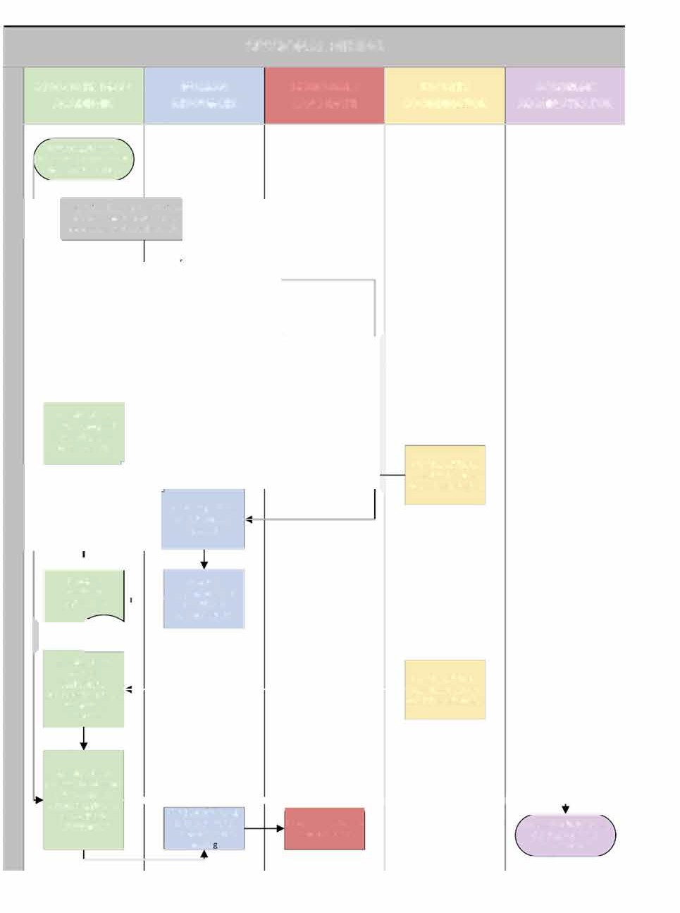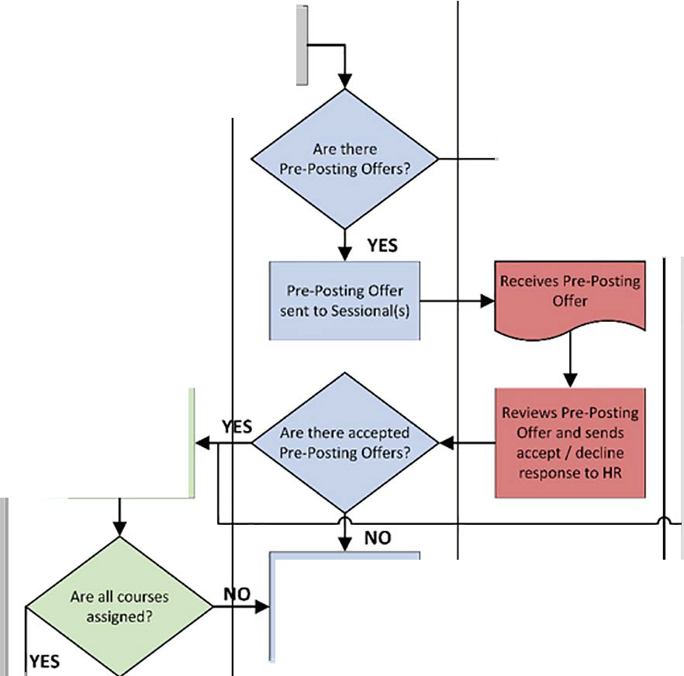
SESSIONAL HIRING
ACADEMIC ADMINISTRATOR
HAZ'J* Z% k6Z%D%Jda
!%df%72ZE*-GA%c!ad)PeY+Si%caPa&6aQ0Ja>a

A993 a=e Dea- c2-9B'@< F >h
Pr$-PPae6F+ O)($[c dQ b$ Ea!%
HR =2 #%e%ZE.M% if e,%Z% aZ%
NO
\
Q((%Za; #0aS%\a%a
eC#eG9 acce4=ed
AaaQc-ad% D%aG

cQlZa%a %o%G>r

course assignments
AaaQc-ad% D%aK QJ
P[Qo-#%a a!o-c% eQ
s&aa3QGa? WQa3g6QIa
are advertlsed/
VQaj%#
SRee9c9e"2!D0ea:(
aVT>-cad6QHa
AaaQc/ad% D%aG
aUV?1cad8QGa, cRG"lcfa 6Gd%^p2%qa, d9eet(eercm>#2in.e9s
^%o0%qa
PZQo-#$a a!o-c$ eQ
caM!8!ai$ a$@%cdAQOa
AbaQc7aj% D$aK QJ
VZQo-!$a P]$-PQad9L*
AaaQc-ad% D%aG
;H Iª J A9 ----------�-r--------------,-�
to Academic
A!E-G:ad^adQ^
Conducts follo !up
c2,!-
0ca2?=?#afydQc2S1%a?8aaBQcG? a%9C
R%c%6o%a NQd-(=caj5QG
cQMd_acd 6a cQE6J+
Aca#%E;c A!E-M<beZadQZ
!%p%>QWa CROdZacj R%Xm%ad )QZEa
0RO'RAM COORDINATOR
SESSIONAL/ CANDIDATE
HUMAN RESOURCES
ASSOCIATE DEAN, ACADEMIC
V`Pn4#$a hQ AbaQc6ad$ D$aJ
a56)R#ceac>e$2#E/e9:a0d

Related Information
2017-2019 Sessional Academic Staff Members Agreement

4.3.1 Account Creation Procedure Pre-Posting Offer Email Template Job Posting Template
Letter of Offer Template

4.3.1 Account Creation Procedure (for new Instructors or Sessionals)
- Following the contract approval for a new instructor or sessional, the Academic Administrator (with support from Academic Administrative Assistants) sends a completed Account Creation Form to the Assistant Registrar.

- The Assistant Registrar will confirm the new instructor does not have an ID number.

- If the instructor does not have an ID number, the Assistant Registrar will send the information to the University of Regina Human Resources Department to create a new ID.

- Once a new ID is created, the Assistant Registrar will send the information to the Academic Administrative Assistant to add to the course information the NEW instructor is to teach.

- The Academic Administrative Assistant will notify University of Regina Grades at uofrgrades@uregina.ca to ensure the NEW INSTRUCTOR is set up in BANNER when a new Instructor/Sessional/Faculty has been hired.

Introduction

Academic Staff (Non-Faculty) Contracts Development
Category: xxx
Number: xxx
Audience: xxx
Issued: xxx
Reapproved: xxx
Owner: xxx
Approved by: xxx
Contact: xxx

Facilitating effective and efficient program and operational administration is a key action involved in delivering on the Teaching & Learning strategic process highlighted in the Strategic Plan. Contracts development and execution is an essential component of this administration, to ensure adequate resources and contracts are in place to deliver on programming to meet the needs of students.

Policy
Timely execution of academic staff (non-faculty) contracts ahead of each semester start is critical for academic operational readiness leading up to class start, including for selected academic staff to prepare for the upcoming semester and for ordering of textbooks which have a lead time for order processing, delivery and placing on shelves in bookstore for students prior to semester start.

FNUniv desires to have an efficient contracts process for academic staff contracts to ensure there is no risk to readiness for semester start which negatively impacts staff and students. This policy is strongly related to the efficient execution of the Hiring Academic Staff (Non-Faculty) policy and process.

ALIGNMENT WITH INSTITUTIONAL CONTRACTS GOVERNANCE
FNUniv developed the Contracts Approval Committee (CAC) in 2018 in order to reduce risk, increase efficiencies and improve accuracy and flow of information at the University. The CAC also intends to break down information silos, increase communication across departments and create further checks and balances as the membership will be representative of all applicable areas of FNUniv. Oversight of the Contracts Process will be increased while facilitating increased collaboration across the University.

CAC membership team and structure includes:

Representing Role | Primary | Secondary
Chair | Vice-President, Finance & Admin | Vice-President, Academic
Academic | Associate Dean, Academic | Associate Dean, Community, Research & Graduate Programs
Finance | Director of Finance | Comptroller
Payroll | Payroll Administrator
Human Resources | HR Recruitment Position | HR Supervisor
Contracts | Contracts Administrator | HR Administrator

CONTRACT GENERATION & APPROVALS
The Contracts Committee (CC) is the forum within the University that generates all contract information. Members of the CC are those vice-presidents, associate deans, directors, librarians, and administrative and executive assistants who are responsible for overseeing and submitting contract request forms. Additional membership consists of a representative from Human Resources. Alternates will also be identified and included in the committee membership list. When requested, observers can attend the meeting.

When contract information is completed by the CC, it is then submitted to the Contracts Approval Committee (CAC) for final approval and processing. All contact requests move through the CC and then to the CAC for final approval. The CC is responsible for collecting, checking and entering all the required information on the appropriate forms for each contract to be entered into by the University. Once all the contract information is verified by the CC the completed forms are submitted to the CAC for final approval and processing.

CONFIDENTIALITY
Members of the CAC will hold discussions and decisions made within the committee with the utmost confidentiality and will not disclose confidential information to anyone outside of the committee if it is not required. Identified members already have access to all information required for CAC actions, however, confidentiality sign off will be required.

TIMELINES
As much as possible, academic staff (non-faculty) contracts should be completed by the following deadlines in advance of semester start:

    - Fall Semester: Contracts in place by end of June
    - Winter Semester: Contracts in place by mid-November
    - Spring/Summer Semester: Contracts in place by end of March

Role and Responsibilities

CONTRACTS TEAM – CONTRACTS ADMINISTRATOR, HR & FINANCE (OWNER)
    - Facilitates contract development and approval process through from contract draft to signoff;
    - Sends reminder email of deadline to submit contract requests prior to Contracts Committee meetings;
    - Drafts academic staff contracts based on Contract Request forms;
    - Reviews contracts to ensure all specific procedures which apply to employment contracts and all employment law requirements are addressed.
    - Reviews contracts to ensure no inordinate legal, financial, or operational risks, including conflict of interest, are presented.
    - Conducts a quality review of contract information and prepares package for submittal to the Contracts

Approval Committee;
    - Obtains appropriate signoffs of contracts once approved and forwards to instructor for acceptance; and
    - Files executed contracts and shares with the Associate Deans, Academic Administrator, applicable Program Coordinator and Payroll.

ACADEMIC ADMINISTRATOR (COMPLIANCE)
    - Submits Contract Request forms for academic staff as selected through the hiring process (with support from the Academic Administrative Assistant) as soon as selections made by Associate Dean;
    - Tracks outstanding contracts to inquire on status with Contract Administrator to get required contracts in place according to semester readiness deadlines; and
    - Keeps Associate Deans apprised of contract status.

VICE-PRESIDENT, ACADEMIC (COMPLIANCE)
    - Act as academic staff (non-faculty) contract signer.

Consequences for Noncompliance
Not having required academic staff (non-faculty) contracts in place in accordance with required semester deadlines may have negative consequences on readiness for semester start, which will have negative impacts on academic staff and students.

Contracts not properly authorized and signed in accordance with this Policy will not legally bind the University and could be reduced or not honoured. In certain cases, the individual signing the contract may incur personal liability, and/or may be subject to discipline by the University, including termination.

Processes

INITIATION OF CONTRACTS PROCESS:
The Contract Administrator sends reminders via email of deadline to submit contract requests prior to upcoming Contracts Committee meetings. The deadline to get a contract on an agenda is the Wednesday before the meeting for the Monday Contracts Committee meeting.

The Academic Administrator (with support from the Academic Administrative Assistant) is responsible for submitted Contract Request forms for academic staff as selected through the hiring process (through pre- posting offer or internal posting or external posting). Contract request forms should be submitted as soon as selections made by Associate Dean to expedite process.

CONTRACT DEVELOPMENT & ADMINISTRATION:
The Contract Administrator develops a draft academic staff contract based on Contract Request forms submitted by the Academic Administrator. The draft is prepared and provided as information to the Contracts Committee for their Monday meetings. The Contract Administrator follows the recommended contract through the process to approval and signoff.

CONTRACT APPROVALS:
The Contracts Committee reviews proposed contracts at its Monday meetings for recommendations for approval to the Contracts Approval Committee. If recommended for final approval, the Contract Administrator will conduct a quality review of information and prepare the contract for submittal to the Contracts Approval Committee for their Tuesday meetings. If approved by the Contracts Approval Committee, the academic staff (non-faculty) contract is provided to the Vice-President, Academic for final review and signoff. Once signed off, the Contract Administrator provides the signed contract to the Instructor for acceptance within 7 days, with a copy to the Academic Administrator and Program Coordinator for tracking purposes. Once acceptance received, the Contract Administrator shares with the Associate Dean, Academic Administrator and Program Coordinator and files, as well as ensures Payroll has a copy of the fully executed contract for Dayforce entry.

The following process map demonstrates the key steps involved with execution of this policy:

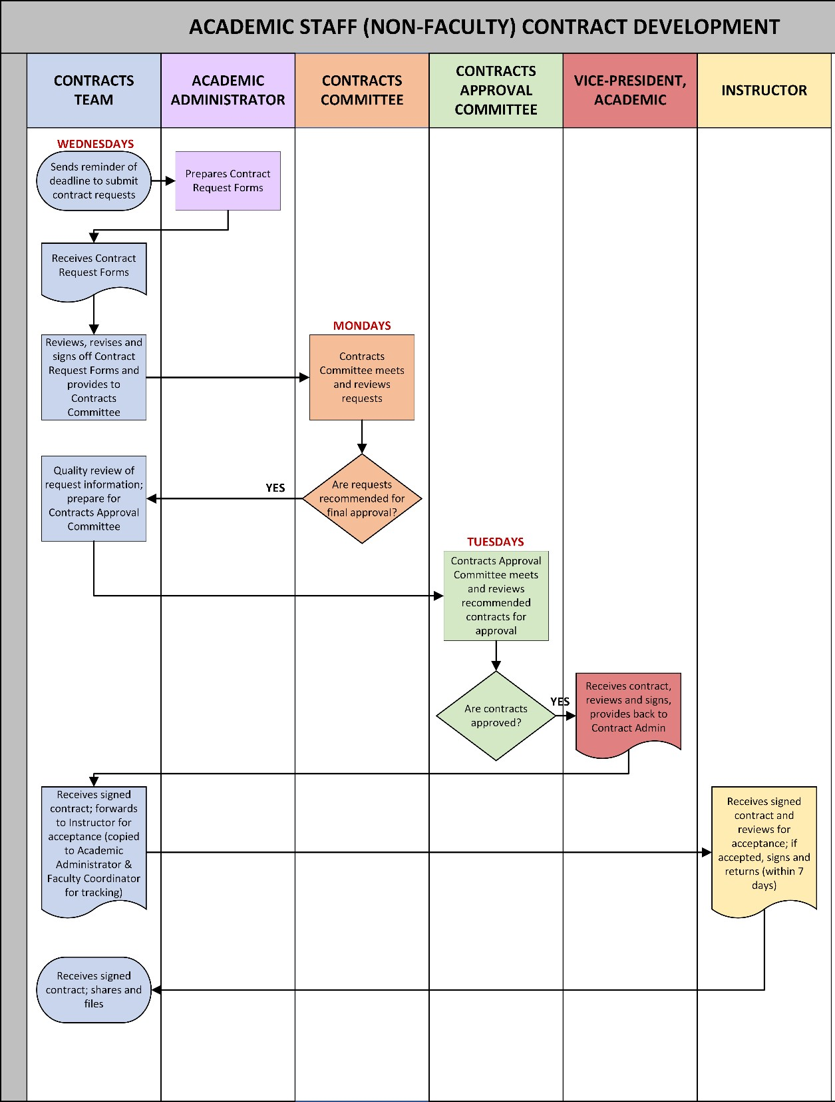

Related Information

FNUniv Contract Approval Process (All Contracts) Contract Request Form
Academic Staff (Non-Faculty) Contract Template

